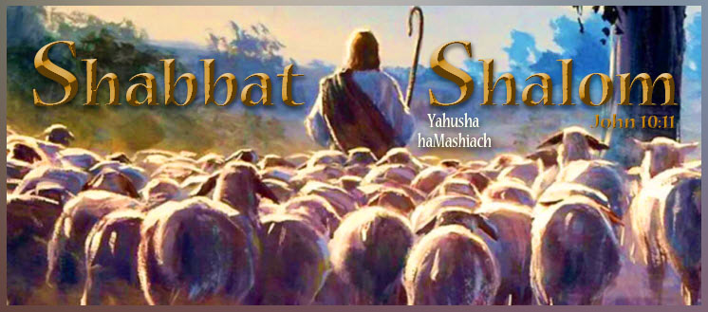

Shabbat Shalom, all who worship Yahuah Alahim and Yahusha haMashiach on their Kadosh (set-apart) New/Renewed Moons, Lunar Sabbaths, and Feast Days according to the full moon as the start of His lunar months!

https://www.youtube.com/watch?v=FUb6QjzvRXU
Today is the 29th day of our Creator’s Tenth Lunar Month count, in which the year begins in the spring. It is also the authentic fourth lunar Sabbath of the month. It looks like 10-29-5994. It coincides with the Roman Gregorian calendar planetary date of Sat, 01-31-2026.
Our Creator placed His full moon beacon as the original New Moon and the start of His months, high above for all to see. All praise to Yahuah Alahim for His steadfast love and compassion for His children and His patience in restoring His lost truths in preparation for the Second Coming of His Son, Yahusha haMashiach (the Messiah). Simply because the full moon as New Moon, with its count to Lunar Sabbaths and annual Feast Days, is not popular among the Rabbinical Pharisee Jews or the Romanized Christian churches today, does in no way diminish its LIGHT OF TRUTH shining from the pages of Scripture and His Eternal Throne. Only Yahuah’s Ruach (power, presence, and provision) gives those who seek Him with all their hearts “eyes to see and ears to hear.” Ask Him today to reveal His New Moon and lunar Sabbath to you, and see how your life will change as your soul temple is synchronized to His for all eternity.
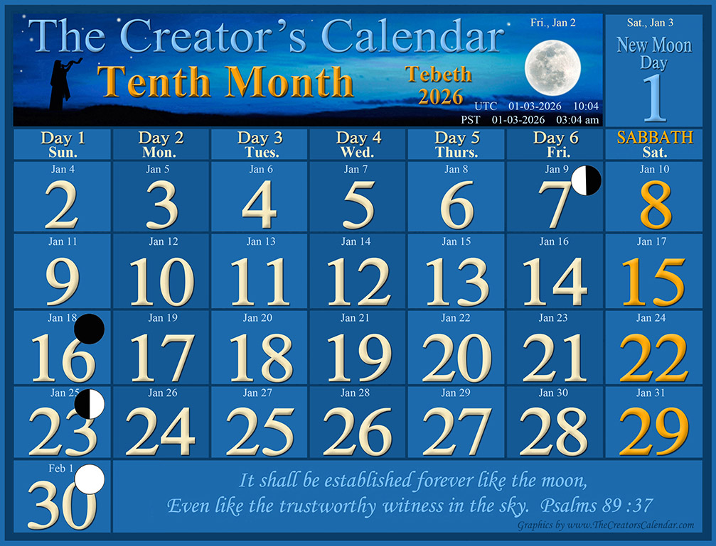

Here is the calendar for the Eleventh Month, which begins on the Gregorian (Mon.):
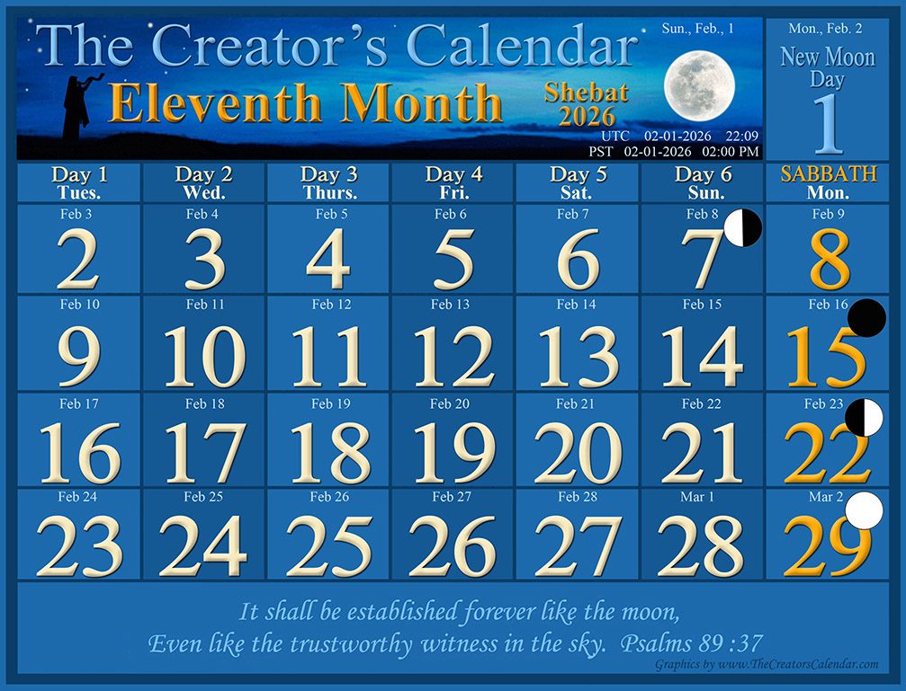
“Blessed are those who hear the joyful call to worship, for they will walk in the light of your presence, Yahuah. They rejoice all day long in your wonderful reputation. They exult in your righteousness.” Psalms 89:15-16
Kerrie’s Korner:

Constantine's Creed
The Forgotten Foundation of ALL Christian Churches
and the Abomination that Makes Desolate
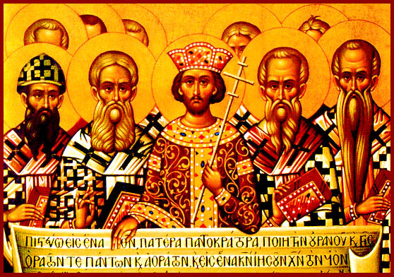

The Creed of Constantinople and the Replacement of Sacred Foundations
[T]The Creed of the Constantinople Church represents the so-called “Christian” legacy formally established under the authority of Emperor Constantine. While often presented as a unifying theological milestone, its underlying purpose was largely political and cultural: to sever the Roman Empire from anything associated with the Yahudim (Jews). In doing so, it did far more than redefine identity. It systematically undermined obedience to the Scriptures, particularly the Torah Law of the Old Testament, which had been given as divine instruction and as the time-centric prophetic framework revealing the Messiah’s mediatorial work of salvation. What had once been foundational was abruptly dismissed and relegated, almost overnight, to the proverbial trash bin.
Just like that, an ancient and well-worn path of truth was obscured. The Torah Law, faithfully preserved for generations as the Creator’s enduring instruction and protective boundary, was removed from view. Yet this Law had been designed not as a burden, but as a gracious guide, a wall of safety through which Yahuah (YHUH) Alahim’s followers, His betrothed Bride, could discern the Plan of Salvation, the remedy unto salvation, and learn how to harmonize their soul temples with His own sacred order.

The Roman Origins of “Christianity”
Most people today are unaware that the term Christian, though widely embraced, is not rooted in the New Testament as commonly assumed, but was popularized and systematized under Roman authority, beginning with Emperor Constantine. Likewise, the title Christ reflects a Greek and Roman rendering that replaced the Hebrew designation Messiah. Despite the appearance of reform, most Protestant churches have never fully separated from their Roman Catholic mother church. Much of her theological DNA, assumptions, and traditions remain intact, from head to toe.
While individual denominations may preserve certain elements of biblical truth, some more closely aligned with Scripture than others, they also retain varying adaptations of inherited pagan traditions. Many believers do not examine Scripture or church history deeply, either by choice or circumstance. Others are intentionally shielded from uncomfortable truths by leadership for the sake of peace, unity, and institutional stability, even when that unity rests upon distorted paradigms. The question remains: why might this matter?

Imperial Decrees Versus the Prophetic Messiah
Historically, the foundational doctrines of much of modern Christianity were shaped not by prophetic continuity but by imperial decree. From the Council of Nicaea under Constantine to later rulings formalized during the Council of Laodicea under Emperor Julian, these decisions carried political authority but no redemptive power. They hold no positive relevance to the true prophetic Messiah of Scripture, to His ordained sin-removing mechanism revealed through the Torah Law as a Bridal Covenant, or to His promise of eternal reward by grace to the humble, forgiven, and obedient.
Not surprisingly, the Creed of the Constantinople Church openly reflects the sentiments and ideology of its architect, Constantine, Emperor of Rome, standing in direct opposition to the Torah of the Old Testament Scriptures.

What Was Lost and Why It Matters
The enforcement of this creed required full compliance from church leadership, including bishops, cardinals, and councils.
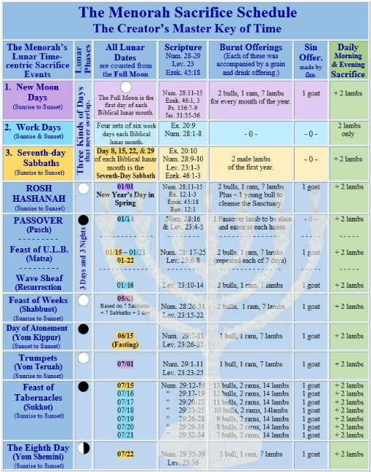
To grasp what was being dismantled, consider the Temple’s Sacrifice Schedule, which visibly ties the appointed times to an ordered, functioning calendar model.
As a result, the entire Tanakh (Old Testament) was effectively dismantled in practice. The Torah Law, the Temple Sacrifice Schedule, its lunar appointed sacred days, the sacred Hebrew names of the Father, Yahuah Alahim/Elohim, and His Son, Yahusha haMashiach, along with the Scriptural calendar revealed through the Temple’s sacrificial schedule, were all discarded.
Yahuah’s preordained years, beginning in the spring, His months signaled by the New Moon, Sabbaths counted from the New Moon, and all His appointed Feast Days were systematically denounced. These divine markers of sacred time were cast aside, and, tragically, so too were the Yahudim themselves during their long Roman captivity. What had been set apart as holy was declared obsolete; what was eternal was treated as disposable.

The Abomination That Makes Desolate
This article seeks to bring these realities into the light. It will demonstrate how a single fourth-century document, the Creed of the Constantinople Church, fulfills what the prophet Daniel twice identified as the abomination that makes desolate (Daniel 11:31–32; 12:11).
"And arms shall stand on his part, and they shall pollute the sanctuary of strength, and shall take away the daily sacrifice, and they shall place the abomination that maketh desolate." Daniel 11:31
"And from the time that the daily sacrifice shall be taken away, and the abomination that maketh desolate set up, there shall be a thousand two hundred and ninety days." Daniel 12:11
Far from being a mere historical footnote, this creed represents a pivotal turning point in which sacred time, sacred law, and sacred identity were deliberately displaced, with consequences that continue to shape religious life to this day.

Constantine's Creed
In the fourth century A.D., loyalty to the Roman state was inseparably bound to loyalty to its sanctioned religion. To be recognized as a faithful Roman citizen, individuals were increasingly pressured to publicly affirm their allegiance by reciting this Creed under oath. What began as a theological declaration quickly became a civic requirement, blurring the line between faith and imperial authority. Compliance signaled acceptance, protection, and social standing, while refusal often invited suspicion, marginalization, or worse. In this way, the Creed functioned not merely as a statement of belief but as an instrument of political conformity, compelling consciences and reshaping religious identity across the empire.

Creed of Constantinople Church
“I renounce all customs, rites, legalisms, unleavened breads and sacrifices of lambs of the Hebrews, and all the other feasts of the Hebrews, sacrifices, prayers, aspirations, purifications, sanctifications, and propitiations, and fasts, and New Moons, and Sabbaths, and superstitions, and hymns and chants, and observances, and synagogues.
Absolutely everything Jewish, every [TORAH] Law, rite and custom and if afterwards I shall wish to deny and return to Jewish superstition, or shall be found eating with Jews, or feasting with them, or secretly conversing and condemning the Christian religion instead of openly confuting them and condemning their vain faith, then let the trembling of Cain and the leprosy of Gehazi cleave to me, as well as the legal punishments to which I acknowledge myself liable. And may I be an anathema in the world to come, and may my soul be set down with Satan and the devils.” Stefano Assemani, Acta Sanctorium Martyrum Orientalium at Occidentalium, Vol. 1, Rome 1748, page 105. [Emphasis mine]
The creed is recorded above in Greek and below in Latin.
“Renuntio omnium mores, ritus, legalisms azymos panes Hebraeorum et sacrificia ex agnis, et solemnitatibus ceteris Hebraeorum sacrificia, vota, appetitiones, purgationes, sanctificationibus procurationesque et ieiunia et in kalendis et in sabbatis et superstitiones, et hymnis, et canticis, et observationibus, et synagogam eorum. Omnia simpliciter Iudaea omnibus legibus implicatus consuetudine ritus postea negare velitis et revertens et Judaica pravitate sive inventus fuerit comedens cum Iudaeis eis convivium, pro Christiana religione aperte an clam condemnare redarguens eos colloquentes condemnare vana fides, tunc et tremore Cain lepra Giezi adhaereat mihi ut et ego agnosco cui subiacet obnoxium. Et ego anathema esse in futuro seculo, et sedi cum Patre meo anima Satanam eiicit daemonia.”
Does this not stand as sufficient evidence that the year, month, week, and days embedded within the Roman-Gregorian calendar, and still followed by churches for so-called holy days, were deliberately engineered to have nothing in common with the Scriptural calendar or the original first week of creation? Rather than emerging from the testimony of Scripture or the divine order established at creation, this calendar system reflects a conscious departure from it, intentionally severing worship rhythms from the very lights Yahuah ordained for sacred time-keeping.

A Second Witness
As a second witness, consider the following testimony attributed to Jerome of Rome, the scholar traditionally credited with translating the Greek Septuagint (LXX) into Latin. As you read his words, consider an important question: Does Jerome appear to recognize a distinction between what later became Roman Christianity and the original followers of the Messiah, who identified themselves as the Natsarim (Nazarenes)?
The Natsarim were those early believers who continued to uphold the entirety of the Torah Law (the Old Testament) while also embracing the sacrificial death of the Messiah on the fourteenth day of the lunar month in spring, offered for the sins of the whole world. These believers did not abandon the faith of Scripture; rather, they understood the testimony of the Messiah as inseparable from it. Yet, strikingly, Jerome labels such faithful adherence as heretical, specifically because these believers honored the Torah Law, including its New Moons, lunar seventh-day Sabbaths, and lunar Feast Days. The gravity of Jerome’s assessment should not be overlooked.
"We shall now especially consider heretics, who... call themselves Nazarenes [Natsarim]; they are mainly Jews and nothing else. They make use not only of the New Testament, but they also use in a way the Old Testament of the Jews; for they do not forbid the books of the Law, the Prophets, and the Writings... so that they are approved of by the Jews, from whom the Nazarenes do not differ in anything, and they profess all the dogmas pertaining to the prescriptions of the [Torah] Law and to the customs of the Jews, except they believe in Messiah... They preach that there is but one god, and His son [Yahusha]. But they are very learned in the Hebrew language; for they, like the Jews, read the whole Law, then the Prophets... They differ from the Jews because they believe in Messiah, and from the Christians in that they are to this day bound to the Jewish rites, such as circumcision, the Sabbath, and the other ceremonies [such as Passover on the 14th of the lunar month]." Jerome - Epiphanius; Panarion 29; translated from the Greek. (Jerome translated Greek Septuagint Bible into Latin language 1,615 years ago, he was an early Roman Christian Church father, here referring to the Natsarim.)
According to Jerome, an early Roman Church father, the true followers of the Messiah were regarded as heretics not because they rejected Scripture, but because they refused to conform to the newly emerging Roman Christian religion and its solar-based calendar system with its non-scriptural holy days. The Natsarim stood apart precisely because they retained fidelity to the faith as delivered in Scripture.

Distinguishing Characteristics of the Natsarim
The Natsarim, the faithful followers of the Messiah, were unique in several key and revealing ways:
- They upheld both Testaments (An Unbroken Bridal Covenant).
The Natsarim remained faithful to the entire Torah Law of the Old Testament while also embracing the New Testament testimony of the Messiah. They saw no contradiction between the two, recognizing them as one continuous revelation.
- They did not reject the Hebrew Scriptures.
Unlike later Roman Christianity, which increasingly marginalized or forbade the Torah, the Prophets, and the Writings, the Natsarim fully embraced them. The suppression of the Old Testament was a development initiated by Roman emperors and church councils in the fourth century A.D., not by the Messiah at the cross, despite what many pastors later have taught.
- They were fluent in Hebrew.
Jerome himself acknowledges their deep knowledge of the Hebrew language. This fluency underscores the reality that the New Testament testimony of the Messiah only finds its full meaning when read through the lens of the Old Testament Hebrew. It also raises the possibility, worthy of further investigation, that the New Testament may originally have been written in Hebrew, and that Greek may have been a Roman ploy to disconnect from the Torah Law.
- They taught the oneness of Alahim.
The Natsarim confessed one Alahim (God) and His Son, Yahusha the Messiah. Notably absent is any reference to a third person of a trinitarian godhead. The doctrine of the Holy Spirit as a separate person emerged later within Roman theology and became one of its central dogmas. In contrast, the Old Testament presents the Ruach haKodesh as the power, presence, and provision of Yahuah and Yahusha, not as an independent being.
- They differed from Jews only in their faith in the Messiah.
The Natsarim followed Yahusha the Messiah, who laid down His life for repentant sinners on the fourteenth day of the first lunar month in spring and rose again after the sixteenth day-night cycle. They proclaimed eternal life through His sacrifice while continuing to live according to the Torah Law and under the righteous covering of the blood of the Lamb.
- They differed from Christians in their obedience.
Unlike Roman Christians, the Natsarim remained faithful to the Torah Law and its divinely ordained, lunar-based worship schedule, including the full New (Renewed) Moon, the lunar seventh-day Sabbath, and the annual lunar appointed Feast Days.
- They followed a different calendar entirely.
The Scriptural calendar observed by the Natsarim was neither the Roman Catholic nor Protestant calendar still in use today, nor the later Rabbinic calendar adopted under Roman pressure during Jewish captivity, which identifies the dark conjunction as the New Moon. Neither did they follow the first visible crescent method employed by Karaite Jews in later centuries.
The sacred days outlined in Scripture cannot be synchronized with the pagan solar calendar designed by the Romans, whose continuous weekly cycle is wholly divorced from the lunar phases. This profound discontinuity stands as compelling evidence of a deliberate alteration of sacred time. Scripture itself identifies such an act as taking away the daily (sacrifice) and in its place setting up the abomination that makes desolate.

The Testimony of Two Witnesses
Here, then, is the testimony of two witnesses: first, the Creed attributed to Constantine, and second, the testimony of Jerome. Together, they affirm that our Messiah never abolished the TORAH, the Law of divine instruction. Rather, it was Constantine, driven by hostility toward all things Hebrew (Jewish), who advanced a newly fashioned replacement religion later called Christianity. In doing so, he ensured that this counterfeit system would share nothing in common with the Old Testament teachings, as the Bridal Covenant, found in the TORAH and the Prophets, including the sacred days appointed on the Creator’s astro-luni-solar calendar. Strikingly, it is under this Roman framework of time-keeping that much of the world continues to live today.
From these two witnesses, one must ask: Is there any evidence that the modern Roman continuous weekly cycle, with its planetary designations of Sunday through Saturday, remains synchronized with the first week of creation? The answer is clear. There is none.
Indeed, this modern calendar system arose from a posture of rebellion and was deliberately designed to undermine the Torah-based order of sacred time. Though its clever construction gives the appearance of harmony with Scripture, it is, in truth, wholly disconnected from the biblical calendar and the time-keeping structure established by the Creator.

Unconcealed Explosion of Evidence
This Creed unmistakably reveals that the TORAH (Law of Instruction) had not come to an end at the time of our Messiah’s crucifixion, as is so often asserted today. Rather, the historical record points to a far later rupture. It was Emperor Constantine who, nearly three centuries afterward, actively severed obedience to the Torah in the process of establishing his newly sanctioned religion, Christianity.
From that moment forward, peace within the Roman Empire came at a steep cost. To avoid being branded a heretic, persecuted, or put to death, individuals were compelled to embrace Constantine’s replacement faith, identified as “Christianity,” along with its newly framed object of worship, “Jesus Christ.” This was not merely a theological shift, but a comprehensive reordering of belief, identity, and allegiance.
Alongside this religious transformation came the imposition of a new system of time. All were required to observe the emperor’s solar calendar, complete with its continuous seven-day planetary week. This innovation laid the groundwork for the long-held assumption that either Saturday or Sunday must be the divinely appointed day of worship. What is rarely acknowledged, however, is that this Roman time-measuring system was enforced under threat of death and was intentionally structured to honor pagan deities, incorporating ancient Babylonian festivals such as Easter and Christmas. By selectively attaching Scriptural language to these pre-scripted pagan observances, Rome effectively repackaged them for widespread acceptance among sincere and trusting believers.
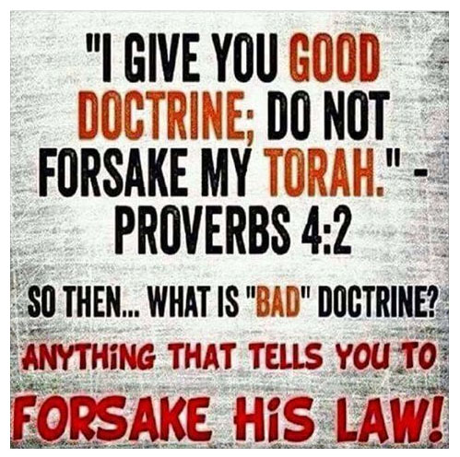
In the centuries that followed, the various Protestant denominations that emerged never fully disentangled themselves from this Roman inheritance. Instead, they continued to seek legitimacy within the framework established by their Catholic predecessor, often at the cost of renouncing all things distinctly Hebrew, including much or all of the Torah’s instruction.
Consequently, to be recognized as “Christian” within this system has historically required submission to the blood-stained Creed of the Constantinople Church, first set in motion in A.D. 325. From that point onward, generations were conditioned to disregard the teachings of YAHUAH preserved in the Old Testament Torah. In their place arose a redefined portrayal of the promised Messiah, bearing a Greek name, and a paganized calendar of solar years, months, weeks, days, and holidays. Tragically, this convergence has led countless sincere worshipers to unknowingly participate in practices far removed from the faith and worship rhythm established by the Creator Himself.

Not Under Law, But Under Grace
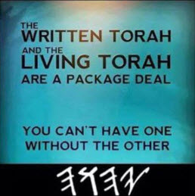
This development laid the groundwork for what would become one of the most foundational teachings within Christian theology: “We are no longer under the LAW but under GRACE.” That assertion was further reinforced through the Roman Christian proclamation that “the LAW was nailed to the cross/stake.” Over time, these phrases were repeated so often that they came to be accepted as self-evident truths, rarely examined in light of the full testimony of Scripture.
Yet this claim was never limited to the Ten Commandments alone, which represent only one portion of the TORAH, the comprehensive Law of Instruction. Rather, the declaration was applied broadly and indiscriminately to the entire body of Torah, despite its integral role in revealing the Creator’s redemptive plan.
Most significantly, the TORAH of the Old Testament contains the time-centric prophetic framework destined to be fulfilled by YAHUSHA, the true Messiah. Throughout His earthly life, in His sacrificial death, and in His resurrection, the Messiah honored and upheld the Torah in both word and deed. Likewise, His disciples and apostles continued steadfastly in this same path. They taught and practiced obedience to the New Moon observances, the lunar seventh-day Sabbaths, and each of the appointed Feast Days, regarding them not as obsolete shadows but as enduring signposts of the covenant.
They understood that walking the Torah life, marked by the celebration of the appointed Feasts seven times each year, was the defining characteristic of the true children of Yasharal (Israel). It is by this very pathway, Scripture affirms, that the faithful are enabled to “follow the LAMB, wherever He goes.”

Nailed to the Cross/Stake
Another widespread assumption taught within many churches is the claim that “all things nailed to the cross/stake came to an end.” This idea has been repeated so frequently that it is rarely questioned, yet it stands in sharp contrast to the testimony of Scripture itself.
In truth, nothing could be further from the biblical record. Everything that was nailed to the cross/stake did not terminate, but rather moved forward into eternity, receiving the highest possible honor. This includes (1) our living and resurrected Messiah, (2) His Covenant, and (3) the TORAH Law of the Old Testament, with its prophetic witness concerning the Messiah and its time-centric mechanism of salvation. Far from being discarded, these realities were sealed, vindicated, and eternally established through the cross.
In this light, the cross/stake may rightly be understood as a divine hinge point in time. Everything fastened to it passed through death into everlasting life. This is the true resolution of the often-misunderstood phrase that “the Law was nailed to the cross.” It was not abolished; it was fulfilled, confirmed, and glorified.
The Messiah Himself left no ambiguity on this matter:
“Think not that I have come to destroy the TORAH Law or the Prophets [Nevi’im]. I have not come to destroy, but to fulfill.” Matthew 5:17
When read carefully, His words dismantle the notion that the Torah was annulled. The idea that everything nailed to the cross was abolished is not a teaching derived from Scripture, but a later theological construct that fails to withstand the full weight of biblical evidence. The concept that everything nailed to the cross was abolished is FAKE NEWS.

Feast Days to be Celebrated throughout Eternity
Yet there is still more to consider. The Messiah’s ministerial work within salvation’s divinely ordered, seven-part framework was never designed to conclude at the cross alone. Rather, it was inaugurated there and continues in the shamayim (the heavenly courts above) until every Feast Day prophecy reaches its full and final fulfillment, and then carries forward into eternity itself. In the age to come, these appointed times will stand as eternal memorials of the love, mercy, and compassion of the Messiah who redeemed His people.
This redemptive framework was not introduced abruptly in the New Testament era. It was first revealed in the wilderness Sanctuary, then carried forward in the Tabernacle, and later embodied in the Temple in Jerusalem. Each structure served as an earthly shadow of the heavenly reality, designed to teach the same unchanging gospel through time, blood, and appointed events. The daily services, the annual Feast Days, and the high priestly ministry all operated according to a precise, time-centric schedule that prefigured the Messiah’s mediatorial work.
Scripture speaks with unmistakable clarity:
"But Messiah being come an high priest of good things to come, by a greater and more perfect tabernacle, not made with hands, that is to say, not of this [human] building. Neither by the blood of goats and calves, but by His own blood He entered in once into the Kadoshim (holy place), having obtained eternal redemption for us... And for this cause He is the mediator of the new testament, that by means of death, for the redemption of the transgressions that were under the first Covenant [TANAKH and TORAH LAW], that they which are called might receive the promise of eternal inheritance." Hebrews 9:11, 12, 15
The wilderness Sanctuary, the Tabernacle, and the Temple were never ends in themselves. They were instructional models, revealing in advance the greater and more perfect ministry of the Messiah in the heavenly Temple not made with human hands. Every sacrifice, every appointed Feast Day, and every priestly action followed the time-centric blueprint of the TORAH, pointing forward to specific redemptive moments in the life, death, resurrection, and ongoing intercession of YAHUSHA haMashiach.
Thus, the entire work of salvation for humanity’s soul temples, first on earth and later within the true heavenly sanctuary, was laid out according to the prophetic timetable preserved in the TANAKH, encompassing the TORAH (Law), the Nevi’im (Prophets), and the Ketuvim (Writings). Together, these sacred witnesses move in perfect harmony, orchestrating PROPHETIC TIMES through SACRED APPOINTED EVENTS, known as the set-apart Feast Days (Kadosh mo’edim).
Divine truth requires that these time-centered prophecies of the Torah can never be altered, displaced, or severed from their appointed events. They can only be fulfilled by YAHUSHA haMashiach, the promised Messiah, the Lamb of Elohim, and our eternal Kohen Gadol (High Priest).

Replacement Terms for the New Distinctly Roman Religion
From the time of the crucifixion of Yahusha haMashiach until the rise of Constantine, a span of roughly three centuries, the Messiah’s true followers were never known as “Christians.” Instead, Roman authorities referred to them as Quartodecimians (meaning fourteeners). This designation was not incidental; it was assigned because these believers steadfastly observed Passover on the 14th day of the first lunar month (Abib), counted from Rosh Hashanah, the first New Moon of the spring. In doing so, they remained faithful to the TORAH’s time-centric commandments and to the example established by the Messiah Himself.
These believers also called themselves Natsarim, identifying with the Messiah of Nazareth and continuing to live within the framework of the Hebrew Scriptures. However, after A.D. 325, this identity was no longer tolerated. Under the threat of persecution and death, the Quartodecimen/Natsarim were compelled to renounce their Torah-centered faith and submit to the newly sanctioned Roman religion now called Christianity. This coercion required a decisive break from their distinctly Hebrew worldview, calendar, and worship rhythm.
Equally striking is the historical reality that the term “Christian” did not exist prior to this era in its imperial sense, nor did the name “Jesus Christ” originate in the apostolic community. Rather, this title emerged through a sequence of transliterations, moving from Greek into Latin and later into English, as illustrated in the accompanying image.
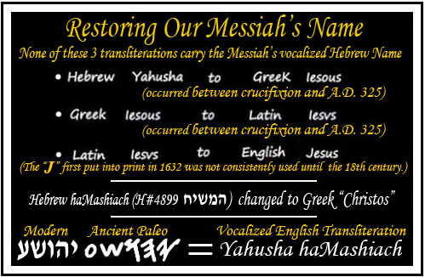
This renaming of the Messiah was not a neutral linguistic development nor a simple matter of translation. It reflected a deliberate refusal by Emperor Constantine and the Roman establishment to honor a Hebrew Yahudim (Jewish) Messiah or to preserve His Hebrew name. In its place, they introduced a name and title that the Messiah’s earliest followers would never have recognized as an acceptable substitute for YAHUSHA haMashiach. It was a name His mother never spoke, a name foreign to the covenantal language of Scripture, and one that marked a decisive shift away from the faith once delivered to the saints.

The Early Believers Were Neither Romans nor Christians
All references to the “early believers” in Scripture and early historical records point unmistakably to the true followers of Yahusha haMashiach, the Messiah. These believers were never participants in an institutional “church” as later defined by Roman Christianity. Rather, they remained faithful and obedient observers of the TORAH Law of Instruction, identifying themselves as part of Yasharal (Israel). They were the ecclesia, the “called-out ones,” a term that, in its Hebrew understanding, denotes people of the sacred assemblies, gathered according to the Creator’s appointed times rather than a man-made religious structure.
In stark contrast to the later Roman Catholic Christian worldview, every authentic reference to the early believers presents one unified community, distinguished by three defining attributes of great consequence:
- They followed YAHUSHA haMashiach, the Messiah, walking as He walked and ordering their lives according to His teachings, example, and appointed times.
- They held fast to the entire TANAKH (Old Testament), embracing the TORAH (Law of Instruction), the Nevi’im (Prophets), and the Ketuvim (Writings) as the authoritative foundation through which the Messiah was revealed and validated.
- They remained faithful to the astro-luni-solar calendar embedded in the TORAH, beginning the year in spring at Rosh Hashanah (the first New Moon), counting fourteen days to locate PASSOVER, and from that anchor point discerning all other sacred appointments exactly as laid out in the Temple’s Sacrifice Schedule.
This final point is critical. The worship life of the early believers was not abstract or symbolic. It was anchored to the Temple’s daily, weekly, monthly, and annual sacrificial service, which functioned as Heaven’s visible time-grid on earth. The Temple Sacrifice Schedule provided the living calendar by which New Moons, lunar Sabbaths, and Feast Days were identified, ordered, and fulfilled. Every sacrifice, offering, and appointed service corresponded to a specific day of the lunar month, revealing a precise and divinely orchestrated rhythm of time and redemption.
For this reason, the Temple’s Sacrifice Schedule is placed here, as it visually demonstrates how the calendar of Scripture operated in real time. It shows how the early believers understood sacred time, located Passover and all Feast Days, and followed the Messiah “wherever He goes” by aligning their worship with the very schedule He Himself fulfilled.
This was not a peripheral matter of custom or culture. It was the structural framework through which redemption, prophecy, covenant obedience, and the Messiah’s ministry were understood. Calendar, covenant, Temple service, and faith were inseparable. To remove any one of these is to fracture the whole.
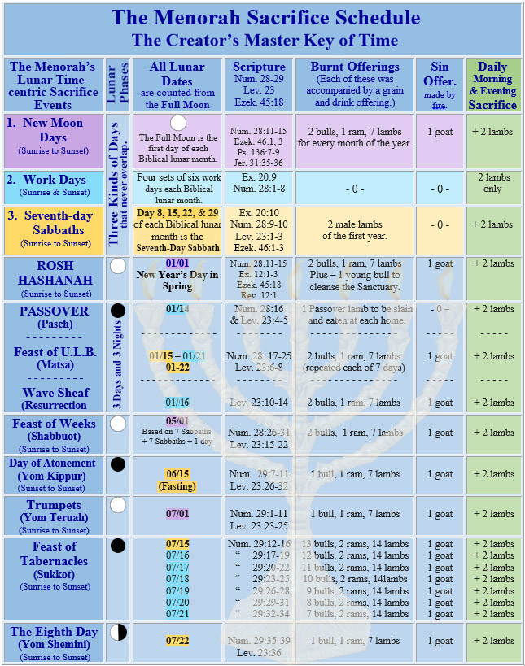

The Scriptural Test for True Covenant Faithfulness
The faithful and obedient Yasharal (Israel) are succinctly defined in Scripture by a single, unyielding standard:
“To the Torah Law [containing commandments, judgments, statutes, and testimonies] and to the Testimony [the Tabernacle of the Testimony and the Feast Day prophecies of the Messiah]; if they speak not according to this word, it is because there is no light in them.”
Yeshayahu (Isaiah) 8:20
This verse establishes a timeless measuring rod. Covenant faithfulness is not determined by popularity, institutional authority, or religious innovation, but by alignment with the TORAH and the Testimony, the very framework through which the Messiah was revealed and His redemptive work unfolded.
Yet in direct opposition to this Scriptural standard, the Papacy (Roman Catholic Church) labored to convince the world that Rome’s newly constructed religion, called Christianity, represented the original followers of the Messiah after His resurrection. In truth, these two realities are separated by several centuries and are never synonymous. Roman Christianity did not preserve apostolic faith; it replaced it.
As Roman influence expanded, all regions under imperial authority were systematically fused into this new religious system. Those who refused to comply, who clung to the TORAH, the calendar of Scripture, and the original testimony of the Messiah, were branded as heretics and persecuted. Acceptance required submission to a new set of customs, beliefs, and mandates that were entirely absent from and often opposed to Scripture itself.
As one historian observed:
“In the year 325 A.D. was perpetrated one of the most colossal frauds and deceptions in the annals of history. This was the date of the Council of Nicaea, whose task it was to create a new religion that would be acceptable to Emperor Constantine…” The Historical Apollonius Versus the Mythical Jesus, Dr. R. W. Bernard, Ph.D.
Likewise, church historian Ben H. Swett writes:
“The Council of Nicaea was a pivotal event in the history of Christianity. The Messiah’s followers called themselves Natsarim but were known to the Romans as Quartodecimen. The term ‘Christians’ was the creation of Constantine in the 4th century A.D. The sudden adoption of a quasi-philosophic term to define the historic Jesus as equal to God was a major departure from Scripture and tradition. From A.D. 325 onward, Nicenes could—and did—proclaim other dogmas that have no basis in Scripture.”
— State Church of the Roman Empire, 1998
Following this shift, mandatory creeds were drafted. Every citizen within the Roman Empire was required to swear allegiance, effectively renouncing the TORAH Law. the first five books of the Old Testament, and abandoning the ancient Scriptural framework of worship. Such oaths included declarations like the following:
“I accept all customs, rites, legalism, and feasts of the Romans… the New Sabbath ‘So! dei’ (day of the Sun, better known as Sunday)… In one word, I absolutely accept everything Roman, every new law, rite, and custom of Rome, and the New Roman Religion.”
This was not merely a theological adjustment. It was a forced severing from the TORAH, the calendar of creation, and the Testimony of the Messiah, precisely the elements Scripture identifies as the source of true spiritual light.

The Council of Laodicea
In A.D. 358, just thirty-three years after the formal establishment of Rome’s new Christian religion and its continuous seven-day planetary week, the Yahudim (Jews), under intense Roman pressure, finalized a sweeping overhaul of their own calendar system. This revision marked a decisive departure from the ancient Scriptural timekeeping model they had preserved for centuries.
Only seven years later, in A.D. 365, the Council of Laodicea, as recorded in the Roman canons, issued the following decree:
“Christians must not Judaize by resting on the [lunar] Sabbath , but must work on that day. Rather, honoring the Lord’s Day [new planetary Sunday]. But if any shall be found to be Judaizers, let them be anathema from Christ.” Council of Laodicea, Canon 29
If we were unaware of the documented evidence showing that the Yahudim had just seven years earlier altered their calendar, including the adoption of Roman Saturday as their new Sabbath, we might reasonably assume, along with many today, that Saturday had always been the Jewish Sabbath. Under that assumption, this legislation could be read as a deliberate effort by Sunday-keeping Christians to distance themselves from Jews by forbidding rest on what had become the Jewish Saturday.
However, the matter is far more complex. This canon may also be addressing the original lunar Sabbath, the Sabbath the Jews had faithfully observed since antiquity, one determined by the moon and counted from the New Moon, not anchored to Rome’s planetary week. In this light, the decree takes on an even more revealing significance.
Whichever interpretation one adopts, the cumulative weight of historical and Scriptural evidence leads to a single, unavoidable conclusion: both Rome and the Jewish leadership of that era altered every unit of time, years, months, weeks, Sabbaths, and sacred days. As a result, neither system in use today faithfully reflects the TORAH Law, the time-centric prophecies of the true Messiah, or the original principles of time-measuring designed to synchronize the Creator’s people with His authentic worship rhythm.
What was lost was not merely a calendar, but a divinely appointed framework of sacred time meant to unite heaven and earth in covenant faithfulness.

A Sobering Admission from Karaite Judaism
Most striking of all is the candid acknowledgment from Karaite Judaism itself, a movement often assumed to have preserved the most ancient biblical calendar. After centuries of warfare, dispersion, and imposed calendrical systems, even they even admit that the original markers of sacred time have been obscured. These pragmatically honest Karaite Jews deserve accolades for the following admission:
“Through all the trials and tribulations that humanity has experienced over the past 5,000 years, we have no proof whatsoever that our current Saturday is the actual seven-day ‘anniversary’ of the original Shabbath of Creation.”
https://www.karaiteinsights.com/article/shabbat.html
NEWS FLASH!!! If the Karaites, for which the Millerites and later the Seventh-day Adventist Church denomination has patterned its historic Day of Atonement (Yom Kippur) event of October 22, 1844, have come to the conclusion that “WE HAVE NO PROOF WHATSOEVER that SATURDAY is the ACTUAL SEVEN DAY ANNIVERSARY of the ORIGINAL SABBATH OF CREATION,” then it is time to sit up and TAKE NOTICE!!! SOUND THE ALARM!!!
The name Karaite means adhering to the Bible only (Sola Scriptura) and not to the Talmud and the Babylonian oral traditions or the Kabbalah. In the same way that the Protestant churches pride themselves on protesting and coming out of Catholicism, the Karaites pride themselves on coming out of Rabbinical Pharisaism, the Talmud, and all the oral traditions of Mystic Babylon. Yet, just as we have discovered that most of Protestantism has not yet come all the way out of the Roman Catholic Church and its errors, including solar time, neither did the Karaites regain all the truths that had been lost over the past 2,000 years, specifically with regard to the calendar, its Full New/Renewed Moon, lunar seventh-day Sabbaths, or the timing of its lunar appointed Feast dates.

What Sunday Keepers Have Known for Years
Few are aware that Sunday-keeping theologians and church leaders have openly acknowledged the true Scriptural Hebrew lunar Sabbath for well over a century. As early as 1916, this knowledge was not only known but documented in scholarly and ecclesiastical publications. Yet, despite this awareness, it has had little to no effect on prevailing worship practices. Why? Because many have declared themselves exempt from obedience, having embraced Constantine’s creed-based doctrine that proclaims, “We are not under the TORAH Law but under Grace.”
One striking example is found in the book Sunday the World’s Rest Day, a volume that has been republished and remains available today. This work is a compilation of presentations from the Fourteenth Congress of the Lord’s Day Alliance (1916)—an organization expressly formed to promote unity around Sunday observance as the Lord’s Day.
Notably, this alliance has long positioned itself in opposition to Saturday Sabbath keepers of various persuasions, fully aware that neither Saturday nor Sunday was ever the original Sabbath of the Hebrews (Israelites) as outlined in Scripture. Their internal acknowledgment of this historical reality only heightens the gravity of what follows.
The admission is remarkable, and the implications are profound. Consider carefully the words that follow.
"The changes in the calendric position of the weekly religious rest day have been few from pre-historic times to the present day. The Sabbath which came down to the Jews from pre-historic [prior to Moses] times was the seventh-day of the lunar week. The lunar week and the lunar month gave the simplest form of time division to early man... Moon and month meant the same thing. The division of the month into four weeks of seven days . . . and the weekly division begun again at the time of the next new moon. The change from the lunar week to the seven-day week running continuously through the year, while a momentous change, was unrecorded. The use of two styles of weeks seems to have existed together, and the more modern seven-day week slowly, but finally, supplanted its ancient... competitor. The lunar week was simple and serviceable... When the continuous seven-day week was generally accepted, then it was linked with the past, as we now date events before Christ by a scale unknown to the people and historians of those times... The lunar Sabbath was succeeded by the seven-day weekly [Saturday] Sabbath without confusion, and the mention of the Sabbath in Exodus 31:13 and elsewhere, may be taken to refer to the lunar day." Sunday the World's Rest Day, "The Sabbath, the Day Which Divine Love Established and Human Love Must Preserve," Theodore Gilman, p. 479. Published for the New York Sabbath Committee, Doubleday, Page and Company, New York, 1916.
The term epagomenal is used to describe intercalary days (as defined by the Oxford English Dictionary), a category that includes New Moon Day and, when it occurs, the 30th day of the lunar month. These days occupy a unique and essential role within the Scriptural time-measuring system. While they are fully counted toward the completion of the lunar month and the astro-luni-solar year, they are not included within the four recurring seven-day lunar weeks.
This distinction is critical. Epagomenal days do not disrupt or alter the four cycling weeks that begin after each New Moon Day. Some have mistakenly labeled these days as “no-days,” but this characterization is incorrect. They are not excluded from time; rather, they exist outside the defined structure of a week. By definition, a week consists of six consecutive workdays followed by one seventh-day Sabbath. New Moon Days and the occasional 30th day do not belong to that formula and therefore stand outside the boundaries of a week, while remaining fully integral to the month and year.
Every day of the lunar month, including the epagomenal days, is counted and distinctly marked by its own unique lunar phase during the moon’s circuit around the earth, described in Scripture as occurring “from one New Moon to another.” This continuous 1–29 or 1–30 lunar phase count ensures that every day is accounted for and properly positioned within the month. Because all lunar phases are included in this system, there are never extra, missing, or uncounted days, ever.
As a result, when one looks to the shamayim (heavens) on a clear night, it is always possible to discern the day of the lunar month, the week, and the day of the week. From the beginning, our Creator designed time in such a way that humanity could know the date and rhythm of sacred time simply by observation. It is a system so elegant and transparent that even a child can understand it. When the sun and stars are added to this celestial testimony, the month of the year can likewise be identified, simply by looking upward after sunset.
For more historical quotes, refer to The Lunar Sabbath's Stunning Historical Evidence.

A Divine Warning: Israel Not to Alter the Set-Time Laws
Through the covenant established with Abraham, Yasharal (Israel) was entrusted with an extraordinary honor, the responsibility of safeguarding the oracles of the PLAN OF SALVATION, the divinely appointed REMEDY for sin. Embedded within this sacred trust was a precise, time-centric revelation of the Messiah’s redemptive ministry, expressed through the lunar-appointed Feast Days that marked His work step by step. Yet even greater than this responsibility was the privilege of bearing the seed of the long-promised Messiah Himself.
However, Scripture reveals that this covenantal honor came with a clear and solemn condition. Obedience was inseparably linked to a specific, predetermined system of time-measuring, one designed by the Creator to govern years, months, Sabbaths, and appointed times. It is within this context that Yahuah Alahim issues a profound warning, tying Israel’s continued standing before Him to their faithfulness in preserving His set-time laws, declaring:
“If you (Yasharel - Israel) shall remove the prescribed SET-TIME LAWS, the oath of the covenant from before My face, declares Yahuah, then indeed (you) the children of Yasharal shall cease from existence and being a nation before My face all the days (forever).” YirmeYAHU (Jeremiah) 31:36
Since the Eternal Yahuah Alahim knows the end from the beginning, is it not reasonable to ask whether He introduced this subject precisely because He foresaw that such a crisis would occur? Might this warning in Jeremiah have been given as a protective safeguard, a gracious alert to His beloved, set-apart people, urging them not to abandon His appointed times?
This leads us to the unavoidable question of our day: Has Yasharal (Israel) removed all or part of Yahuah Alahim’s prescribed set-time measuring model? The answer, though difficult, is clear, yes, yes, and yes. Every unit of sacred time has been altered. Not a single element remains fully intact according to the recorded Kadosh (sacred) standard entrusted to them.
This tragedy did not occur only once. It first unfolded in YirmeYAHU’s day, after which a measure of restoration was granted. Yet the same pattern reemerged with devastating permanence in the fourth century A.D. Unlike earlier periods, these calculated and willful calendar alterations were never reversed. To this day, the original time-measuring framework established at creation remains unrecovered.
Thus, while this study began by examining Constantine and the Christian churches, which openly abolished the Torah’s truths, including the Creator’s calendar, it must also be acknowledged that the Jewish leadership likewise succumbed to altering the sacred things they were commissioned to guard. This sobering reality levels the field entirely. All have fallen short. All stand in need of restoration.
And yet, in this shared failure lies a shared invitation, an open call from a merciful Creator to return, to restore what was lost, and to once again walk in harmony with His sacred times and redemptive design.
“In AD 351-352 Roman persecution flared and the Jews revolted. They were soon crushed. Many Jewish towns were destroyed and decrees issued against the local authorities and against Judaism. The privileges of the head of the Sanhedrin and the freedoms of the Sanhedrin itself were curtailed. Roman pressure to conform “Jewish” TIME to Roman TIME had reached crisis level. ibid
Under this pressure Hillel II agreed to limit the functions of the head of the Sanhedrin, as well as the Sanhedrin itself, with respect to proclaiming the New Moon, setting festival dates, and employing intercalation [inserting the 13th lunar month]. With the decline of the Jewish power-base in Israel, the Jewish community in Babylon had been rising in influence to fill the vacuum. Hillel II published details informing all Jews of the methods of the [new] calculated calendar developed in Babylon. From that time on the Sanhedrin in Judea ceased to function or to maintain calendar experts. Hillel II is thus given the credit for the present fixed Rabbinical calendar, but in reality it originated in Babylon and was just the starting point of the development of the Rabbinical calendar in use today.” Encyclopedia Judaica, s.v. “Hillel.”
The continued use of the Roman continuous seven-day week by modern Yasharal (Israel), the unbroken cycle from Sunday through Saturday, stands as clear evidence that the nation remains, in a very real sense, in Roman captivity. This captivity is no longer political or geographic, but embedded in the measurement of time itself, shaping worship rhythms in ways inherited from Rome rather than from the TORAH.
In A.D. 358, under severe Roman pressure to abandon the Scriptural calendar, Jewish leadership adopted both a Babylonian dark or crescent New Moon and Rome’s continuous weekly cycle, a system entirely divorced from the lunar phases. This replaced the original lunar-based week, which had always restarted after each New Moon and was anchored to visible heavenly signs. Though external forms of observance were preserved, the foundational structure of sacred time was altered, leaving a calendar no longer synchronized with the Creator’s original design.

Rules of Postponement
The forced union of these two incompatible time systems produced an entirely new problem for the Yahudim (Jews), utter calendrical chaos. In an effort to manage the resulting disorder, an additional synchronizing mechanism had to be invented. This solution became known as the Rules of Postponement, a construct devised solely to reconcile irreconcilable systems. Significantly, these rules did not exist before the calendar overhaul, nor were they necessary while the Scriptural time-measuring model remained intact.
What followed was, and remains to this day, a kind of calendar charade, the manipulation of time through artificial rules and calculations. How can this be demonstrated? Quite simply: for centuries, while the Creator’s original timekeeping system was faithfully observed, there was never a conflict between the Sabbath and the Feast Days. Both were derived from and harmonized by the same divinely appointed beacons of time, the sun, the moon, and the stars. When these celestial witnesses were properly employed, sacred time functioned with flawless unity.
In this way, the warning given through Jeremiah (YirmeYAHU), the voice of YAHUAH Alahim to Yasharal (Israel), has been fulfilled at least twice in history. First, during the Babylonian captivity in 605 B.C., brought on by disobedience, and again following the Roman captivity after A.D. 70, when the nation rejected the Messiah, the very benefactor of their promised eternal inheritance.

Yasharal Remains in Captivity Today
If Yasharal (Israel) has indeed removed the principles of Yahuah’s original time-measuring system without restoration, then where does that leave the nation today in light of Jeremiah (Yirmeyahu) 31:36? Scripture answers soberingly. It places them outside His divine protection and apart from the PROMISE manifested through Yahusha haMashiach, the Messiah, for their eternal future.
As difficult as this truth may be to receive, YAHUAH Alahim has clearly stated His case. Not a single soul will receive an eternal reward on that final GREAT DAY on the basis of genealogy alone. Salvation has never been inherited by bloodline. Rather, the opportunity for redemption is continually extended by our loving Eternal Father through the outstretched arms of the Messiah, calling all people to reformation and restoration. GRACE is freely offered to all, but SALVATION is granted only to those who respond to grace with obedience to His TORAH Law of Instruction. Grace was never intended to abolish obedience. It was given to empower it. The TORAH remains the Bridal Covenant, and to be received as His bride, one must be found without spot or wrinkle.
The clearest evidence of a converted heart is revealed in trusting obedience to the MOST HIGH, particularly to His time-honored TORAH and its time-centric calendar model, designed to synchronize worship with YAHUAH Alahim and Yahusha haMashiach in Ruach and in Truth. This is the only pathway by which humanity may truly follow the Lamb wherever He goes (Revelation 14:4). From full New Moon to full New Moon, and from lunar Sabbath to lunar Sabbath, all Zadok (righteous) flesh shall come and worship before Yahuah Alahim (Isaiah 66:23). When these weekly rhythms are joined with the prophetic Feast Days, each counted from the full New Moon, the result is a complete, blood-sealed roadmap provided by the Messiah alone leading unto Eternal Life.
Only those aligned with this divine framework will recognize that the promised Messiah came on time the first time and will return again at the appointed time, exactly as foretold. Indeed, TIME, the Creator’s original astro-luni-solar calendar, and the EVENT of Yahusha haMashiach laying down His life for mankind are forever intertwined. Remove either one, and the whole collapses. United, they stand, and divided, they fall.
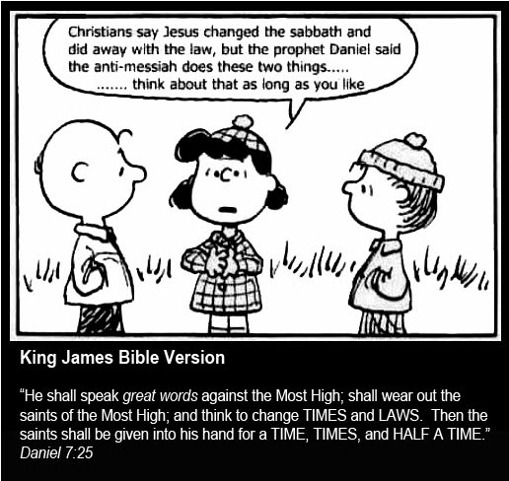

Evidence that Saturday Sacredness was Never Changed to Sunday!
Unfortunately, many Sabbatarians today, unaware of their own history, continue to assert with confidence that the Sabbath of Scripture is unquestionably Saturday, the seventh day of the pagan Roman calendar. In doing so, they often repeat the claim that the Council of Laodicea transferred the sacredness of Saturday to Sunday. This assertion, however sincere, is historically and Scripturally incorrect. Remarkably, the Laodicean decree does not speak of “Saturday” at all, but of the Hebrew lunar Sabbath, which is an entirely different day anchored to a different calendar system. These two Sabbaths belong to two distinct time-measuring models, and to conflate them is to misunderstand both history and Scripture. The assumption that the calendar of creation operates on the same principles as the Roman Julian and later Gregorian solar calendars is therefore without foundation. For a fuller treatment of what actually changed, see the article Constantine and the Week.
The first difficulty with the Saturday assumption is that Rome itself abandoned lunar timekeeping long before Constantine. In 45 B.C., Julius Caesar reformed the Roman calendar by eliminating the moon and introducing a continuous week detached from lunar phases. Before this reform, Rome employed a lunar-based system with weeks counted from the New Moon. This historical reality alone makes it impossible to project the modern Roman week backward into the biblical creation account. Something significant was altered, but it was not a transformation of Saturday into Sunday.
“In the mid-1st century B.C. Julius Cæsar invited Sosigenes, an Alexandrian astronomer, to advise him about the reform of the calendar, and Sosigenes decided that the only practical step was to abandon the lunar calendar altogether. Months must be arranged on a seasonal basis, and a tropical [solar] year used, as in the Egyptian calendar.“ Encyclopedia Britannica. “The Julian Calendar.
“Christians must not Judaize by resting on the Sabbath, but must work on that day. Rather, honoring the Lord’s Day [Sunday]. But if any shall be found to be Judaizers, let them be anathema from Christ.” Council of Laodicea, Canon 29
As Encyclopedia Britannica explains, regarding the Julian reform, Julius Caesar, advised by Sosigenes of Alexandria, determined that the only practical solution was to abandon the lunar calendar altogether and adopt a purely solar year. This severed the Roman calendar permanently from the moon. When the Council of Laodicea later decreed, “Christians must not Judaize by resting on the Sabbath,” the term Sabbath did not refer to Saturday as we now know it. At that moment in history, three distinct options existed. First, the original Hebrew lunar Sabbath, counted from the New Moon, which Constantine had openly denounced. Second, Saturday, the seventh day of Rome’s new planetary week, which the Jews had recently been pressured to adopt. Third, Sunday, Dies Solis, the first day of the Roman week, which Constantine promoted as the official Christian worship day.
Whether by deliberate design or by the mechanics of Rome’s planetary week, Sunday’s position as the first day caused Saturday to fall consistently as the seventh day of that system. This arrangement gave the illusion that Saturday had always been the seventh-day Sabbath of Scripture. In truth, it had not. The original Sabbath of the Yahudim was located “from one New Moon to another” within the Hebrew astro-luni-solar calendar.
It is therefore essential to recognize that the Sabbath observed by the Yahudim prior to the fourth century A.D. was not the same day, nor even the same calendar, as the one adopted during Roman captivity. Before that time, Israel adhered to the TANAKH and the TORAH Law alone, beginning years, months, weeks, and days with the New Moon and counting seven days to each lunar Sabbath. This is precisely why Constantine’s creed bitterly denounced all things Jewish. His pagan worldview was rebranded as “Christian,” and the Jews were coerced into surrendering the very calendar that bound them to the TORAH, their Creator, and the promise of the Messiah who takes away the sins of the world.
"Declaring the new month by observation of the new moon, and the New Year by the arrival of spring, can only be done by the Sanhedrin. In the time of Hillel II [4th century A. D.], the last President of the Sanhedrin, the Romans prohibited this practice. Hillel II was therefore forced to institute his fixed calendar, thus in effect giving the Sanhedrin’s advance approval to the calendars of all future years." The Jewish Calendar: Changing the Calendar, www.torah.org.
"My people are destroyed for lack of knowledge. Because you have rejected knowledge, I also will reject you from being Kohenim (Priests) for Me. Because you have forgotten the Torah of your Elohim, I also will forget your children." HoshaYAH (Hosea) 4:6
The historical record shows that neither early obedient Jews nor faithful Messiah followers ever kept Saturday as their Sabbath until after A.D. 358, when Hillel II, under Roman prohibition, instituted a fixed calendar to preserve outward appearances while abandoning the original system. At that time, the declaration of the New Moon by observation was forbidden, forcing the adoption of a calculated calendar aligned with Rome’s continuous week.
Everyone living in that era understood that “Sabbath” and “Saturday” were not synonymous. They represented two different days governed by two different calendars. Only as historical memory faded did Saturday come to be assumed as the biblical Sabbath. This loss of knowledge fulfills the prophetic warning of Hosea, that the people would be destroyed for lack of knowledge because they had forgotten the TORAH of their Elohim.
The planetary week itself was a pagan counterfeit of the biblical week instituted at creation. Long before Rome, this system originated in ancient Babylon as part of sun worship and stood in direct opposition to the Creator’s design. Rome merely perfected and enforced it through imperial authority, ultimately binding the entire world to a rebellious timekeeping system.
"This planetary week was paganism’s counterfeit of the true Biblical week instituted by the Creator in the beginning of earth’s history. In the counterfeit week, employed in ancient paganism, “the venerable day of the Sun” was esteemed by the heathen above the other six days because it was regarded as sacred to the Sun, the chief of the planetary deities . . . Just as the true Sabbath is inseparably linked with the Biblical week, so the false Sabbath of pagan origin needed a weekly cycle. Thus we have found that the planetary week of paganism is Sunday’s twin sister, and that the two counterfeit institutions were linked together …" Odom, op. cit., p. 243-244, emphasis supplied.
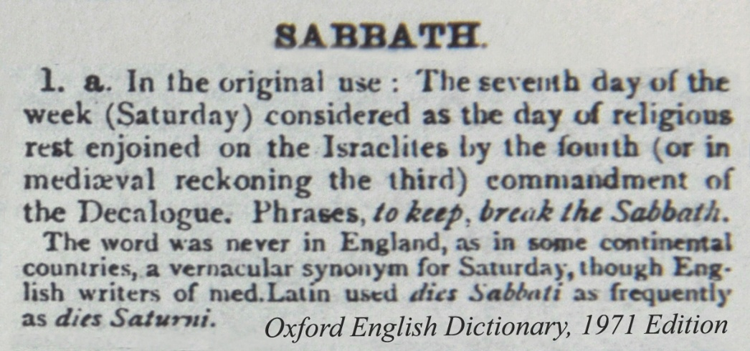
Today, the world continues to march in step with Rome’s calendar. Under the banner of Christianity, countless churches worship the Creator using a replacement name and an illegitimate calendar, unaware that sacred time itself was altered at the root. What appears familiar and unquestioned is, in fact, the legacy of a deliberate and far-reaching substitution.

Does Your Church or Synagogue Carry the DNA Torch of the Roman Mother Church?
If truth holds genuine value for you, it is worth pausing to consider whether one or more of the following indicators may reveal that your Christian church or synagogue still carries the DNA of the Roman Catholic mother church, thereby remaining tethered, however subtly, to the Beast system and its Mark. This is not an accusation, but an invitation to thoughtful self-examination grounded in history, Scripture, and conscience.
History reminds us that institutional reform rarely comes from within. Just as Martin Luther ultimately discovered that he could not reform the Roman Catholic Church from the inside, so too no sincere seeker of truth should expect to effect systemic change within today’s religious institutions. Transformation does not occur through ecclesiastical structures, but through individual hearts awakened by truth. Real restoration begins one soul at a time, as knowledge replaces tradition and obedience is restored to its rightful place.

Indicators of Roman Mother church DNA
A church or synagogue may still carry the imprint of Rome if it reflects one or more of the following characteristics:
- Like Constantine, it worships Jesus Christ as the Son of God in place of YAHUSHA haMashiach, who came in the name of His Father YAHUAH Alahim, written in Hebrew more than 7,000 times in the Tanakh (Old Testament).
- Like Constantine, its members identify themselves as Christians, even though this term did not exist in its imperial sense until Constantine institutionalized it in A.D. 325.
- Like Constantine, it worships the title “Lord God” as a replacement for YAHUAH Alahim, the Eternal Father.
- Like Constantine, it follows the rhythm of the pagan Roman solar calendar (Julian or Gregorian) for all worship occasions.
- Like Constantine, it identifies either Saturday (Dies Saturnis) or Sunday (Dies Solis) as sacred days on a Roman calendar specifically designed to oppose the creation week revealed in the TORAH.
- Like Constantine, it celebrates New Year’s Day on January 1st in winter, rather than Rosh Hashanah on the full New Moon of Abib 1 in spring, as prescribed in Scripture.
- Like Constantine, it denounces the New Year in spring, New Moons, lunar Sabbaths, and the lunar-appointed Feast Days outlined in the TORAH.
- Like Constantine, it follows a continuous seven-day week rather than the Scriptural week that begins and ends with the New Moon.
- Like Constantine, its wall calendars display months and dates with no consistent synchronization to the Creator’s designated lunar phases.
- Like Constantine, it teaches that believers are no longer under the TORAH Law, claiming it ended at the crucifixion, while asserting a covenant of Grace alone. Yet it was Constantine, not Yahusha haMashiach, who abolished Hebrew obedience in A.D. 325.
- Like the mother church, it misapplies the phrase “the Law nailed to the cross” to mean the TORAH was abolished.
- Like Constantine, it celebrates Christmas on December 25, a date historically tied to pagan deities rather than the Messiah.
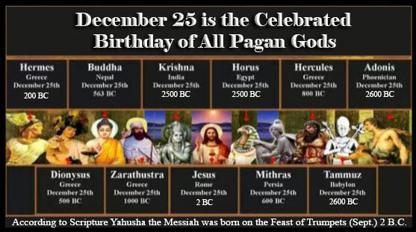
- Like Constantine, it celebrates the death, burial, and resurrection of the Messiah on Easter Sunday, deliberately severed from the Scriptural Passover and Wave Sheaf Offering. Scripture appointed Yahusha to die on Passover, the 14th of Abib, and to rise on the 16th, marking Him as the true Messiah.
- Some Saturday keepers substitute quarterly communion for Passover, despite Passover being precisely counted fourteen days from the first full New Moon of spring.
- Many teach that souls go immediately to heaven or hell at death, though Scripture teaches that all remain in the grave until the resurrection and judgment at the Messiah’s return.
- Some promote prayer to saints, images, or Mary as an intercessor, teachings absent from Scripture.
- Some acknowledge the Vatican as the Beast of Revelation, yet overlook evidence suggesting that Rabbinical Pharisee Judaism, through calendar alteration, has aligned with Rome in changing times and laws.
- Nearly all churches believe the Mark of the Beast cannot affect them, assuming their denomination provides immunity.
- Saturday Sabbatarians often believe Saturday observance alone prevents receiving the Mark, while Sunday worshipers believe Grace exempts them entirely. Both positions arise from a lack of historical and calendrical understanding.
- Like Constantine, churches generally fail to recognize that both the Roman calendar alteration and the Rabbinical Jewish calendar alteration produce the Mark of the Beast, because both abandon the Creator’s appointed times.
This is not written to condemn, but to awaken. The question before each of us is not what we have inherited, but what we are willing to examine, unlearn, and restore in obedience to the truth as it is written.


Historical Lunar Week and Sabbath Quotes
The widely held belief that the modern continuous weekly cycle has descended uninterrupted from Creation is not a conclusion shared by informed Jewish scholars who are well acquainted with their own history and with the immovable tenets of Torah Scripture. On the contrary, historical evidence strongly suggests that Jewish leadership between the second and fourth centuries, in concert with Roman authorities, played a significant role in the profound alterations to calendation, the system of sacred time-measuring now accepted by the world.
These changes did not occur through a minor adjustment, but through the deliberate setting aside of the Creator’s original calendar, the one beaconed by His ordained trinity of lights: the sun, the moon, and the stars. By disconnecting sacred time from these celestial witnesses, the original worship rhythm established at Creation was obscured, giving rise to the calendar confusion that persists to this day.
“The connection of the Sabbath with lunar phases, however, was (later) discarded by the Israelites . . .” The New Schaff-Herzog Religious Encyclopedia, p. 135-136.
“In the years following Clement of Alexandria’s time (A.D. 150-215), an ominous change started to take place that was to radically change the Christian concept of the Sabbath.” This intimate connection between the week and the month was soon dissolved. It is certain that the week soon followed a development of its own, and it became the custom — without paying any regard to the days of the month (i.e. the luni-solar month) . . . so that the New Moon no longer coincided with the first day of the month. Then, on page 4179 of the same encyclopedia, we read: “The introduction . . . of the custom of celebrating the Sabbath every 7th day, irrespective of the relationship of the day to the moon’s phases, led to a complete separation from the ancient view of the Sabbath. . . Encyclopaedia Biblica, 1903 p. 5290.
Even after Constantine’s edict about Sunday [A.D. 321-324], it took another generation or two for the seven-day week to catch on throughout the empire. The 24-hour system took longer, having to wait until the invention of the mechanical clock in the Middle Ages by monks anxious to observe with precision their canonical hours. Before this, people marked the passage of time during the night by using the stars and during the day either by eyeballing the sun or by listening to public announcements of the time.” Calendar, David Ewing Duncan, p. 47, New York, Avon Books, 1998.
“The invention of the continuous week was therefore one of the most significant breakthroughs in human beings’ attempts to break away from being prisoners of nature [time preordained by the Creator with the correct use of the sun, moon, and stars] and create a social world of their own.” The Seven Day Circle: The History and Meaning of the Week, Eviator Zerubavel, New York: The Free Press, 1985. p.11.
“Most theologians and some scholars assume that mainstream Jewish society, at the time of Jesus…was practicing a fixed seven-day week, which was the same as the modern fixed [Roman planetary cycling] seven-day week. This is extremely doubtful. The change, from a lunar to a fixed week, was brought about by the power and influence of Rome. As long as the Nazarenes held power in Jerusalem, all Roman practices and customs, including that of the consecutive week, were held at bay.” Shawui Sabbath: Ancient Sabbath Observance
“The [early] Hebrews employed lunar seven-day weeks, which ended with special observances on the seventh day, but none the less were tied to the moon’s course.” Rest Days, Hutton Webster, p. 254-255
“He [Constantine] wished, almost the necessity, of so keeping Easter as to make the day of crucifixion Friday, and of the resurrection Sunday, caused differences of opinion that led to persecution and bloodshed.” Mazzaroth, The Constellations, Frances Rolleston, p. 133. Rivingtons, London, 1862.
“The Jewish festivals being regulated solely by the moon, may fall on any day of the [modern Roman] week.” Oxford English Dictionary, 1971 Edition, Vol. 2, “Pentecost.”
“The modern seven-day week came into use during the early imperial period, after the Julian calendar came into effect, apparently stimulated by immigration from the Roman East. For a while it coexisted alongside the old 8-day nundinal cycle, and fasti are known which show both cycles. It was finally given official status by Constantine in 321.” Roman Calendar Encyclopedia, Days of the Week.
“The Sabbath depending, in Israel’s nomadic period, upon the observation of the phases of the moon, it could not, accordingly be a fixed day [planetary day of the modern Roman cycling week]. The Jewish Encyclopedia: A Descriptive Record of the History. Edited by Isidore Singer, Cyrus Adler. Volume 10, p. 590.
“It is certain that the Jews celebrated the sheaf-waving on Nisan 16 and Pentecost on the fiftieth day after . . . without regard in either case to the day of the [modern Roman] week.” Oxford English Dictionary, 1971 Edition, Vol. 2, “Pentecost.”
“We shall be taken for Persians [Mithraists], perhaps . . . The reason for this, I suppose, is that it is known that we pray towards the east . . . Likewise, if we devote the day of the Sun to festivity (from a far different reason from Sun worship), we are in a second place from those who devote the day of Saturn, themselves also deviating by way of a Jewish custom of which they are ignorant.” Tertullian, Apologia.
The weeks do not continue in a regular cycle regardless of the moon. Each month has four weeks, their beginning with the New Moon. I have no doubt that this was the old Hebrew system. Babylonian Menologies and the Semitic Calendars, p. 89.
“It should be noted that the oldest dated Christian inscription to employ a planetary designation [Sunday – Saturday, unbroken cycle of weeks] belongs to the year 269 A.D.“ Inscriptiones Christianae Urbis Romae, ed. De Rossi, 1861, i, No. 1.
“The present Jewish calendar was fixed [to the Roman planetary weekly cycle] in the fourth century.” Jewish Theological Seminary of America, Letter by Louis Finkelstein to Dr. Leroy E. Froom, Feb. 20, 1939.
“There was a distinct break between the Old Testament requirements . . . dealing with the Sabbath worship… They wanted to show that Christianity was distinct from Judaism… The other thing that we should remember, too, is that our calendar that we follow, including Seventh-day Adventists, is not only a calendar that was devised by the Catholic Church, but also it is a calendar that’s based upon the solar year, not the lunar year and the Jewish calendar that was observed in the time of Christ follows a lunar [lunisolar] calendar . . . So the great irony is that even the Seventh-day Adventists themselves are not worshiping on exactly the same Sabbath day as the Jews of the time of Christ.” Patrick Madrid, Catholic University Professor made the startling comment on EWTN, Global Catholic Radio Network on Jan 5, 2006 when answering a question about the Catholic Church changing the day of worship from Saturday to Sunday.
With a subtle yet decisive gesture, Constantine affixed Dies Solis (Sunday) to the Resurrection of our Messiah, thereby making his own calculated contribution to severing sacred time from the Yahudim (Jews). To the untrained eye, and to generations unfamiliar with the historical record, this maneuver created the powerful illusion that Scripture’s original seventh-day Sabbath had always been “Saturday.”
This illusion was sustained by a simple but effective mechanism: ensuring that Easter was observed every year on Sunday, the first day of Rome’s newly imposed planetary week. By extension, the day immediately preceding it, Dies Saturnis (Saturday), was made to appear as the seventh day of that same cycle. Yet according to Scripture and the ancient calendar of Creation, this alignment had never existed before.
“The long-term effect was that ‘Easter Sunday’ entered the Christian paradigm as ‘The Day of Christ’s Resurrection.’ The corollary to this realignment of time calculation was that the day preceding Easter Sunday, Saturday, became forever after ‘The True Bible Sabbath.’ This is the true significance of Constantine’s ‘Sunday law’ and it laid the foundation for the modern assumption that a continuous weekly cycle has always existed.” eLaine Vornholt & Laura Lee Vorholt-Jones, Calendar Fraud, “Biblical Calendar Outlawed.”

Rethinking the Abomination that Makes Desolate
A closer reading of Daniel reveals that the abomination that makes desolate is inseparably linked to time itself, not merely to a political act or a future event. Daniel first introduces this concept in Daniel 11:31, where we are told that forces would arise to take away the daily sacrifice and set up the abomination that makes desolate. This language is not symbolic filler. It points directly to the Temple’s daily sacrifice schedule, which was governed by a precise, time-centric framework rooted in the Creator’s calendar. To remove the daily sacrifice was to disrupt the very rhythm of sacred time established by Yahuah.
Daniel 12:11 deliberately repeats this same narrative, reinforcing its importance: “From the time that the daily sacrifice is taken away, and the abomination that makes desolate is set up…” What follows is not a vague warning, but a measurement of time: a thousand two hundred and ninety days. This repetition confirms that the abomination is not only an act of desecration, but a calculated alteration of appointed time, severing worship from the calendar that sustained it.
It is worth considering, then, whether this numerical period itself may have been obscured or manipulated to prevent recognition that the prophecy had already been fulfilled. Daniel 7:25 provides critical context, warning that this same power would “think to change times and laws.” The wording is precise. It does not merely say laws, but times and laws together, suggesting a coordinated effort to alter both divine instruction and the calendar by which it is kept. If sacred time was changed, then the prophetic clock tied to that time would necessarily be distorted as well.
Viewed through this lens, the abomination that makes desolate is no longer confined to a distant future expectation. It emerges as a historical reality rooted in the removal of the Temple’s daily, time-regulated service and the substitution of a counterfeit system of time. This understanding not only harmonizes the testimony of Daniel’s visions but also explains why so many sincere believers have struggled to locate the fulfillment. When time itself is altered, recognition is delayed. Yet the prophecy remains accurate, waiting patiently for eyes willing to see and hearts willing to reconsider what has long been assumed.

Conclusion
Have we been mistaken for much of our lives in our sincere desire to be called “Christian,” while simultaneously dismissing the continued viability of the Torah, the Law of the Old Testament? Have we been conditioned to turn a blind eye to the original time-measuring model established at Creation, with its New Moons, lunar Sabbaths, and lunar-appointed Feast Days, simply because we were taught that we are now “saved by grace” and therefore no longer accountable to the Torah? In many cases, the honest answer is yes, not out of rebellion, but out of inherited ignorance. Yet every passing moment presents a fresh opportunity for correction, restoration, and a return to truth.
When viewed through this lens, the long-anticipated abomination of desolation takes on sobering clarity. Many have assumed it was destined solely for the end of time, yet the historical and theological evidence points decisively to its fulfillment in the fourth century A.D. It was then that sacred time was severed from the Torah, the Creator’s appointed calendar was replaced, and a foreign system of worship was enthroned in its place. What was holy was made common, what was eternal was treated as obsolete, and the dwelling place of truth was left desolate. Far from undermining Scripture, this reality confirms it. Prophecy did not fail. It was fulfilled, precisely as foretold.
The historical record, including the Creed associated with Constantine and the Church of Constantinople, openly acknowledges that the Hebrews marked their months by the New Moon in accordance with the Torah. It was not Saturday of Rome’s sun-based calendar that Constantine sought to abolish, but Yahuah Alahim’s lunar Sabbath and the entire Torah-anchored worship rhythm tied to it. The original seventh-day Sabbath of Scripture was not the same day later adopted by the Rabbinical Pharisee Jews under Roman coercion in A.D. 358. What they retained was the Roman Saturday, a planetary day shared with the pagan world. This distinction is difficult for many to accept, yet the evidence is unmistakable.
For those who have considered alternative calendar systems, such as the Enoch solar model or proposed future world calendars, the same historical clues offer clarity. The calendar practiced by the Hebrews prior to A.D. 325 was neither purely solar nor Roman in origin. It was lunar in its time-measuring foundation, governed by the moon as the primary beacon of sacred time. Not every lunar phase qualified to commence the month, but the full moon alone functioned as the appointed signal for New Years, New Months, and the count toward all sacred days. This was the calendar Constantine moved decisively to eliminate.
During Roman captivity, the Hebrews were compelled to relinquish the continued authority of Yahuah’s Torah, along with His New Moons, lunar Sabbaths, and sacred appointed Feast Days. To this day, that original time-keeping model, faithfully observed by the Patriarchs and Prophets for over four millennia, has not been fully restored. Consequently, both Rabbinical Judaism and the broader Christian world remain bound to Roman time. In this way, the abomination that began in the fourth century continues to cast its long shadow across the present. As history testifies, Rome stands as the successor of ancient Babylon, inheriting its authority and methods, and Scripture identifies this power as central to end-time deception.
And so we find ourselves standing at the threshold of the closing chapters of history. The revelation that the abomination of desolation has already occurred does not lead to despair, but to responsibility. It lifts the veil, removes the blinders, and calls a people to reexamine everything they have inherited. As Scripture speaks of the Beast power, shaped by ancient Babylon and carried forward through Roman authority and its creeds, the urgency of our Messiah resounds through His messengers, calling out with unmistakable clarity:
"BABYLON THE GREAT IS FALLEN, IS FALLEN . . ." Revelation (Hazon) 18:2
". . . COME OUT OF HER, MY PEOPLE, LEST YOU SHARE IN HER SINS, AND LEST YOU RECEIVE OF HER PLAGUES." Revelation (Hazon) 18:4

My people are destroyed for lack of knowledge. WHY? Because you have rejected knowledge, I also will reject you from being Kohenim (Priests) for Me. Because you have forgotten THE TORAH (LAW) of your Elohim, I also will forget your children. Hosea (HosaYAH) 4:6

“Our beliefs, right or wrong.
If right, to be kept right;
and if wrong, to be set right.”
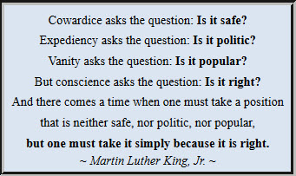
May our conscience rise above politics and popularity as we come to understand that Constantine’s fourth-century Creed redirected the Christian world away from the sacred names, the true Messiah, the authentic calendar, and the holy appointed days of Yahuah Alahim. What was lost was not accidental, but deliberately removed from view. Yet the present moment stands as an open door. Now is the time to recover what was set aside and to return, with humility and courage, to obedience in all that Yahuah has lovingly prescribed.
May He extend continued compassion to us all as we awaken from spiritual slumber and respond to His call to step away from man-made systems and into the full light of His truth. This preparation is not merely academic, but eternal in consequence, as we ready ourselves for His impending judgment and the establishment of His everlasting Kingdom government. The call remains clear and urgent: COME OUT and be separate.

Please follow up this article with these related articles:
- Constantine and the Week
- Constantine's Creation of Jesus Christ
- Constantine's Easter Controversy with the Messiah's Quartodecimen
- Mo'edim and the Missing Key Puzzle Piece

The following is a Christian’s challenge and a Rabbi’s rebuttal of the quote's premise.

Hunting the Wild Misquotation
Posted on May 17, 2010 by Roger Pearse
As I wander around the web, I come across supposed quotations that slap me in the face and shriek at me as “fake.” Today, I found this:
The following creed is that of a church at Constantinople around the time of the “Council of Nicea”:
“I renounce all customs, rites, legalisms, unleavened breads & sacrifices of lambs of the Hebrews, and all other feasts of the Hebrews, sacrifices, prayers, aspersions, purifications, sanctifications and propitiations and fasts, and new moons, and Sabbaths, and superstitions, and hymns and chants and observances and Synagogues, and the food and drink of the Hebrews; in one word, I renounce everything Jewish, every law, rite and custom and if afterwards I shall wish to deny and return to Jewish superstition, or shall be found eating with the Jews, or feasting with them, or secretly conversing and condemning the Christian religion instead of openly confuting them and condemning their vain faith, then let the trembling of Gehazi cleave to me, as well as the legal punishments to which I acknowledge myself liable. And may I be anathema in the world to come, and may my soul be set down with Satan and the devils.”
Do you think that this religion (Constantinianism) is what Yeshua wanted us to become entangled in?
This is a canon of Nicaea I. It sounds like a personal confession of faith. The poster, of course, gave no reference. But a Google search on I renounce all customs, rites, legalisms, unleavened bread & sacrifices of lambs of the Hebrews gave me this link at Fordham.edu, which said nothing about Nicaea and gave “From Assemani, Cod. Lit., 1, p. 105″ as the reference, and “from James Parkes: The Conflict of the Church and the Synagogue: A Study in the Origins of Antisemitism, (New York: JPS, 1934), 394-400.”
Assemani was an oriental scholar who published texts from Syriac in Rome in the 18th century, most of them medieval. So, this also is not in accord with the starting post.
Adding Assemani to the Google search brought up a slew of material such as this, headed Constantine’s and Rome’s Christian Creed, giving “Stefano Assemani, Acta Sanctorium Martyrum Orientalium at Occidentalium, Vol. 1, Rome 1748, page 105” as the reference for the very same paragraph.
We’re clearly in the realm of the polemical quote when we have two references for the same thing. Of course, “Sanctorium” is itself a typo, but suggestive of someone who has repeated, rather than checked, the data.
Is the book online? Not in Google Books or archive.org — not a good start.
What about the “Cod. Lit.” reference? This site tells us that J. A. Assemani published, inter alia:
“Codex Liturgicus ecclesiae Universae in XV libros distributus” (Rome, 1749-66). — This valuable work has become so rare that a bookseller in Paris recently issued a photographic impression of it.
So the “quote” has two references, neither readily accessible, both in Latin at best.
Volume 8 of the codex Liturgicus is here, and several others are accessible. Is volume 1, I wonder? After a lot of searching, I found it here. Page 105 is p.162 of the PDF. The renunciation starts at the top of p.106 and starts as per the quote.
But … it’s misleading. This is not the whole statement. A huge chunk has been omitted from the middle without being marked. For it should at least indicate the omission: “In one word, I renounce everything Jewish, every law, rite and custom … And if afterward I shall wish to deny”. In fact, the sentence before the break is truncated, and the one afterward starts before the ‘and.’
I renounce everything Jewish, legalism, custom, and rite; and above all, he who is expected by all the Jews in the shape and dress of Christ, I renounce Anti-Christ, and join myself to the true Christ and God. And I believe in the Father, the Son, and the Holy Spirit; the holy and consubstantial and individual Trinity; I profess the dispensation where one of the holy trinity, the Word of God, took flesh and became man; …
And later:
…if I pretend to be a Christian and then I wish to deny and return to Jewish superstition…
I don’t have time to translate the whole confession, but the extracts are more than a little misleading.
The other question — is this Nicene? — must be answered in the negative. There is no trace of such a statement in all this. No, this is a medieval Greek catechism for someone converting to Christianity from Judaism.
Quite why the Christians should not require a Jew professing conversion to be sincere, of course, we are not told by the original post.

Rebuttal by OvadYah
November 12, 2014 at 10:01 am
Thanks, Roger – I read your sobering critique against the hordes of posts on the internet that promote this ‘Constantine Creed.’ I admit that I found this particular Creed promotion too, ‘obviously’ stating the truths of history’s great anti-Semitism and hate against anything Jewish – except, of course, the very Bible that was authored mainly by Jews – including the ‘New Testament’!
True, in sober research, one often gets across (and should be wide awake against) this exuberance of most of modern day’s ‘Hebrew Roots Restorers’ seeking confirmation of their newfound ‘restored true Faith.’ This modern notion is so volatile these days that it could well point to a (mis)interpreted ‘anti-missionary’ onslaught by Jews – as suggested by one of your respondents, Kevin.
Kevin (receiving your agreement), in fact, confirmed my surmising while reading your sobering guidance of another danger inherent in the highlighting of the probable (mis)quotation by these exponents. Kevin’s views, in one swoop, cover up ALL the evidence of the GREAT Jew hatred of the Church from the time of its birth to this day (to various degrees, of course). Typically, as of the media apparatus with all they wish to sweep under the carpet, this treatment of the ‘uncovering of the (mis)quotes against Constantine’ places doubts on ALL the ‘evidence’ of history of the barbarous treatment of Jews simply for sticking to the faith of their ‘mamas and papas’ right up to Moses who was taught and enlightened by God. In fact, Kevin style, we could now even doubt the authenticity of Moses! Never mind the lion’s dens of Rome (NOT for Christians but for ‘Jewish style’ Messianics of the time!). Never mind Luther and Calvin’s venom and insult of Jews and everything Jewish! Never mind ….. ALL the awful hatred revealed by Christians against Jews and Judaism. Today, that hatred (SEE definition of hate!) is covered under a cloak of ‘love’ for Israel and Judaism – indeed a true love, infiltrated through by the bitter waters of centuries of Constantine Christianity. If you doubt these statements, which we are faced with daily in dealing with Hebraic Roots Restorers, then please ask the nearest Christian to you what he/she thinks of Rabbinic authority and the Oral Torah.
Irrespective of which of the libraries of ‘evidence’ of Christian hatred of Jesus’ own religion is (mis) quoted or not, ONE salient point of evidence stands unchallenged today: Millions of Christians are leaving the Constantine-originated institutions of Christianity and RETURNING to their ancient ROOTS of that hated Jewish ‘customs, rites, legalisms, unleavened bread & sacrifices of lambs of the Hebrews, and all other feasts of the Hebrews, sacrifices, prayers, aspersions, purifications, sanctifications and propitiations and fasts, and new moons, and Sabbaths, and superstitions, and hymns and chants and observances and Synagogues, and the food and drink of the Hebrews.”
I do not believe that casting doubts on the authenticity of “Constantine-like Decrees” can answer for the sound foundations (MUST BE!!!) of this ‘Turn Around’ by multi-millions of souls throughout the world to a Faith which they, the Returnees and Restorers themselves, have rejected before!
So, I commend your alertness – but please be aware that it does NOT sanctify the birth effects of Constantine’s Decrees and attitude, which poisoned the entire world against God’s One True Faith – Judaism. Interpret this approach as you wish, but do NOT lose sight of what the main message of Prophetic Scripture itself proclaims – as, in fact, confirmed by the authentic Jewish Torah principles hidden in the NT itself, which are, in fact, turning its truly seeking readers around to the very principles that Constantine and Christianity vehemently discarded.
Ref. http://www.kolhator.org.il and note the publication “Jewish Secrets Hidden in the NT” on display – written by an orthodox Rabbi.
OvadYah – co-founder KOL HATOR VISION for a restored Israel (of Jews and non-Jews who seek God’s True Way of Judaism.

Kerrie French’s final comments:
It was in response to the Jews rejecting the Messiah outright that the Good News of the Gospel was carried on the wings of the Gentiles. Yet, while they accepted the Messiah, they rejected the Torah Law of the Old Testament, causing the TRUTHS of SCRIPTURE to become defaced in the process. The Torah Law, which was recorded as the Promise and Purpose of the Prophetic and Time-centric coming of the Messiah, was thwarted, and in its place a fraudulent focus and time system was established.
So, both sides, the Jews and Christians, rejected one of the two pillars of Scripture. The prophet Isaiah explained it this way:
"To the Torah Law and to the Testimony, if they speak not according to this word, it is because there is no light in them." Isaiah 8:20

Song: Bring Me Back / A Cry for Redemption and Peace ~ Messianic Worship Song
https://www.youtube.com/watch?v=fPBy61yrpEI

Prayer:
Most High Yahuah Alahim,
open our eyes to discern how sacred time was altered and how the
daily testimony of Your appointed worship was taken
away, just as You foretold through Your prophets.
Remove the veils of tradition and assumption from our hearts,
that we may recognize the abomination that
brought desolation and acknowledge that Your
Word has proven true in
every generation.
Grant us humility and courage to return to Your appointed times,
walking in restored obedience as we prepare for the full
revealing of Your Kingdom through
Yahusha haMashiach.
Barak hashem Yahusha haMashiach!
(Bless the name of Yahusha the Messiah!)

Kerrie French
www.TheCreatorsCalendar.com
TheCreatorsCalendar29.5@gmail.com
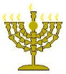

Below is a world map of those visiting TheCreatorsCalendar.com at this very moment in time. The purpose of showing you these is to encourage you and help you know that you are not alone. Many are waking up as Yahusha’s still, small voice speaks to each heart. Only those who “seek with all their heart” will find. (Jeremiah 29:13)


This is from the exact moment in time, but an enlargement of the USA, so you can see the details.


The chart below shows the top 16 most popular articles read at this very moment. To read any of these, simply go to www.TheCreatorsCalendar.com and type the article name in the search bar provided near the top left corner of this web page.
