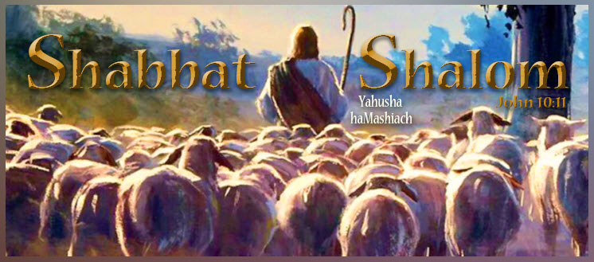

Shabbat Shalom, all who worship Yahuah Alahim and Yahusha haMashiach on their Kadosh (set-apart) New Moons, Lunar Sabbaths, and Feast Days according to the full moon as the start of months!

Today is the eighth day of our Creator’s Eighth Lunar Month count that begins in the spring. It is also the authentic first lunar Sabbath of the month. It is coincident with the Roman Gregorian calendar planetary date of Sun., 11-05-2023.

Our Creator placed His full moon beacon as the original New Moon and the start of His months, high above for all to see. All praise to YAHUAH Alahim for His steadfast love and compassion for His children and His patience in restoring His lost truths in preparation for the Second Coming of His Son, Yahusha haMashiach (the Messiah). Simply because the full moon as New Moon, with its count to Lunar Sabbaths, and annual Feast Days is not popular among the Rabbinical Pharisee Jews or the Romanized Christian churches today, does, in no way diminish its LIGHT OF TRUTH shining from the pages of Scripture and His Eternal Throne. Only YAHUAH’S Ruach (power, presence, and provision) gives those who seek Him with all their hearts “eyes to see and ears to hear.” Ask Him today to reveal His New Moon and lunar Sabbath to you and see how your life will change as your soul temple is synchronized to His for all eternity.

“Blessed are those who hear the joyful call to worship, for they will walk in the light of your presence, YAHUAH. They rejoice all day long in your wonderful reputation. They exult in your righteousness.” Psalms 89:15-16

AS A MAN CARRIES HIS SON
Jonathan Cahn

We watched from a mountain ridge as a family of nomads made their way across a barren plain. The father was carrying in his arms his infant son.
“As a man carries his son,” said the teacher. “When is it that a man carries his son?”
“When his son is a baby,” I replied.
“Yes, and when else?” he asked.
“When his son is too tired to continue walking, or when his son is sick or disabled.”
“And when else?”
“When he holds his son…to embrace him?”
“Did you know that it is written in the Scriptures that, as that father is to his infant son, so YAHUAH Alahim (God) is to His people? When the Israelites reached the end of their journeying, Moses told them, ‘You saw how YAHUAH your Alahim carried you, as a man carries his son, in all the way that you went until you came to this place.’ Remember this mental image of a man carrying his son. It’s a picture of Alahim and His people…It’s a picture of Alahim and you. The wilderness journey is a symbol of our journey through this life.
So in your journey through this life, there will be times when you’ll find yourself too weary to go on. It will be then that He will carry you in His arms. And there will be times when you find yourself with infirmities, wounds, disabling wounds, brokenness, and some way unable to go on. It is then that He will carry you. And when you find yourself in a valley, down, in the lowest times of your life, and unable to raise yourself, it will be then that His hand will grab hold of yours and lift you up. And there will be times when you feel alone and abandoned. And it will be then that the arms of your Father will hold you and embrace you. You will not see His arms with your eyes and only sometimes will you feel them. But they will be there, always lifting you up, always keeping you, always holding you, and always carrying you on, to bring you to the appointed place and day.”
He was quiet as he stared at the family still making its way across the plain.
“And there is one other time,” he said, “that a man will carry his son…when his son has died. And so when you close your eyes for the last time in this life, the arms of your Father will once more hold you and [ultimately at the appointed time] bring you from this wilderness into the Promised Land…as tenderly and as lovingly as a man carries his son.”
The Mission: Thank YAHUAH Alahim for the times in your life when you couldn’t go on, but YAHUAH Alahim (God) carried you. Let those same arms carry you and your burdens now.
Deuteronomy 1:31; Song of Solomon 8:5; Isaiah 40:11; Isaiah 46:3-4; John 10:27-29.
[Disclaimer: Please note that “The Book of Mysteries” is Jonathan Cahn’s notes from the lessons he received while spending a year under the tutelage of “The Teacher” in Yasharal (Israel). I have found many of these to be worthy to share and will make additional comments on them as needed. Those teachings not supported by Scripture that don’t meet the mark on any level are not shared or posted. We are not followers of Jonathan Cahn as there are many beliefs we don’t hold in common. However, these are shared that you too may be barakah (blessed) by the wisdom of “The Teacher.”]

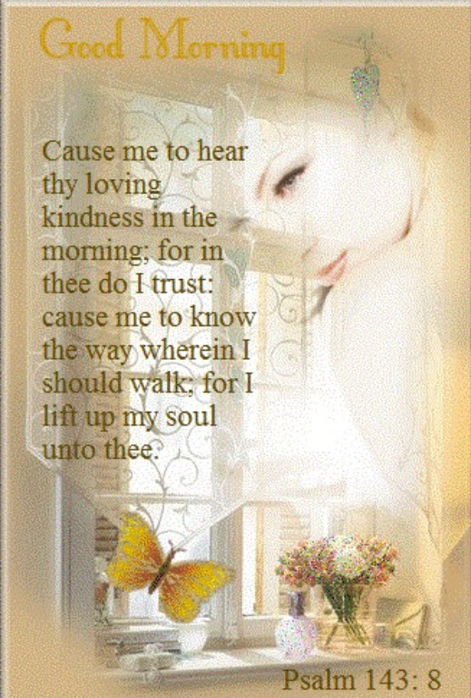

Kerrie’s Comments

Someone sent me the following video this week exploring whether Islam is a religion of peace. This is presented as a debate in which the audience votes for the truth after both sides have presented their views. It is so well done, I encourage each of you to watch it in light of the current Islamic uprising in Gaza and Iran. I believe it is so important to become clear on this subject. It will be worth your while.

Is Islam a Religion of Peace?

Song: My Refuge ~ Deluge
Preserve Me ~ James Block

Barak hashem YAHUSHA haMashiach! (Bless the name of YAHUSHA the Messiah!)

Kerrie French
www.TheCreatorsCalendar.com
TheCreatorsCalendar29.5@gmail.com
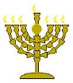

Below is a world map of those visiting TheCreatorsCalendar.com website at this very moment in time. The purpose of showing you these is to encourage you and help you know that you are not alone. Many are waking up as the still small voice speaks to each heart. Only those who “seek with all their heart” will find. (Jeremiah 29:13)

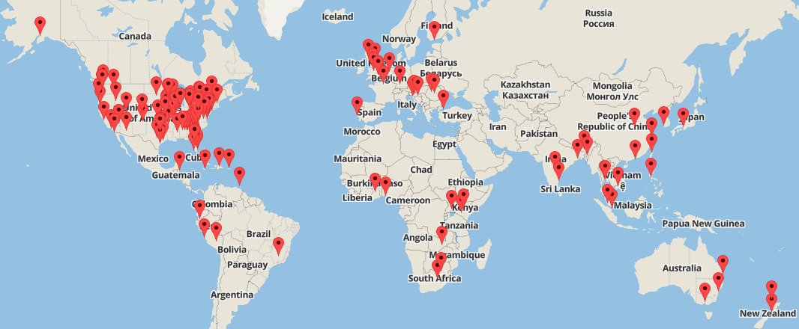

This is from the same moment in time but just an enlarged image of the USA so you can see the details.

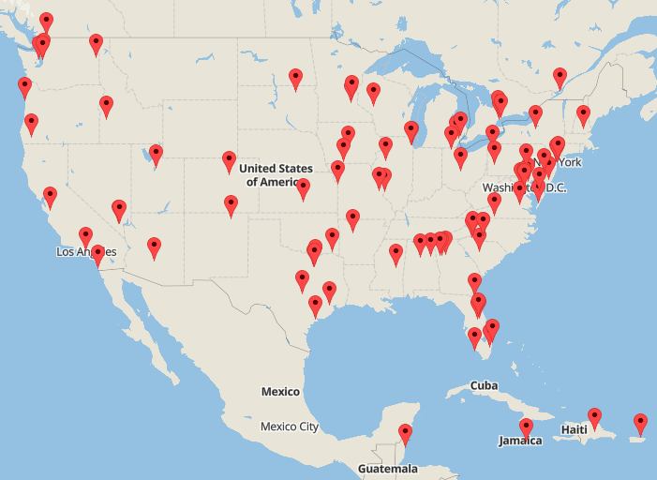

The chart below shows the top 20 most popular articles read at this very moment. To read any of these, simply go to www.TheCreatorsCalendar.com and type the name in the search bar provided on the left side of this website.

