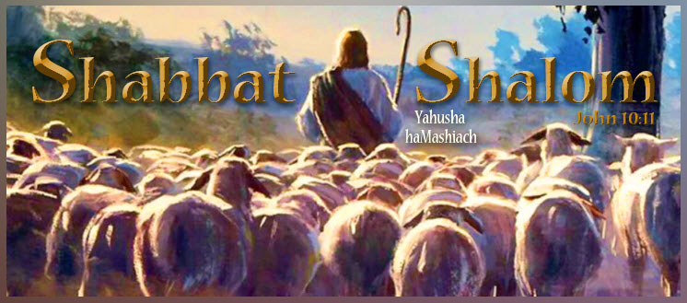

Shabbat Shalom, all who worship Yahuah Alahim and Yahusha haMashiach on their Kadosh (set-apart) New Moons, Lunar Sabbaths, and Feast Days according to the full moon as the start of His months!

Today is the 29th day of our Creator’s Thirteenth Lunar Month count that begins in the spring. It is also the authentic fourth and last lunar Sabbath of the month and year. It coincides with the Roman Gregorian calendar planetary date of Monday, 04-22-2024.

Our Creator placed His full moon beacon as the original New Moon and the start of His months, high above for all to see. All praise to YAHUAH Alahim for His steadfast love and compassion for His children and His patience in restoring His lost truths in preparation for the Second Coming of His Son, Yahusha haMashiach (the Messiah). Simply because the full moon as New Moon, with its count to Lunar Sabbaths, and annual Feast Days is not popular among the Rabbinical Pharisee Jews or the Romanized Christian churches today, does, in no way diminish its LIGHT OF TRUTH shining from the pages of Scripture and His Eternal Throne. Only YAHUAH’S Ruach (power, presence, and provision) gives those who seek Him with all their hearts “eyes to see and ears to hear.” Ask Him today to reveal His New Moon and lunar Sabbath to you and see how your life will change as your soul temple is synchronized to His for all eternity.

“Blessed are those who hear the joyful call to worship, for they will walk in the light of your presence, YAHUAH. They rejoice all day long in your wonderful reputation. They exult in your righteousness.” Psalms 89:15-16

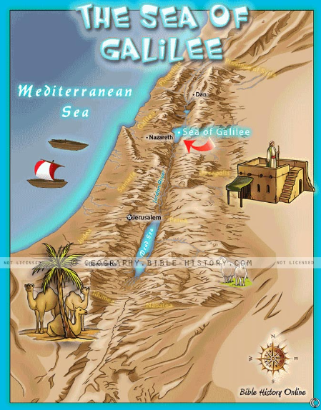

THE TWO SEAS
By Jonathan Cahn

“The Promised Land has two seas,” said the teacher. “One is called the Kinneret, or the Sea of Galilee. The Sea of Galilee receives its water on its northern end from the inflow of the Jordan River. On its other end is its outflow. There it becomes the Jordan River again flowing southward.
“And the other sea?”
“The other is called the Sea of Salt, or the Sea of Death.”
“The Dead Sea.”
“Yes,” he said. “It’s called the Dead Sea because virtually nothing can live there. There’s no fish and no vegetation. Its salt and minerals prevent life from growing.”
“And where does the Dead Sea get its water from?” I asked.
“From the Jordan River and the Sea of Galilee.”
“So it’s the same water.”
“Yes,” he said.
“Then why is it dead?” I asked.
“The difference is that the Dead Sea only has one opening to the north where it receives water from Jordan. But it has no outlet. The water only pours in…and becomes dead. But the water of the Galilee is alive, freshwater filled with fish. And yet the very same water flows between the two. So how can the same water produce life in one place and death in the other?”
“Because of the outlets,” I answered.
“That’s right,” said the teacher. “But shy?”
“I don’t know. I was only guessing.”
“The Sea of Galilee is always giving what it receives. It’s always flowing. But the Dead Sea only receives and never gives. So the life that gives of what it receives, the life that always blesses others, that life is the Sea of Galilee. Its waters are always fresh. It’s always filled with life. But the life that only takes and doesn’t give, that life becomes dead and barren…and all with the same waters. You see,” said the teacher, “it’s not what you have in this life, how much or how little, that, in the end, will matter. It’s what you do with what you have. If you only take, the waters become dead and your life becomes the Dead Sea. But if you give, then the waters become alive and your life becomes…the Sea of Galilee.
The Mission: Live this day after the pattern of the Sea of Galilee, always receiving and always giving. Live to be a blessing in the flowing of His love. Proverbs 11:24; Matthew 10:8; Luke 6:38; 2 Corinthians 9:6-11.

[Disclaimer: Please note that “The Book of Mysteries” is Jonathan Cahn’s notes from the lessons he received while spending a year under the tutelage of “The Teacher” in Yasharal (Israel). I have found many of these to be worthy to share and will make additional comments on them as needed. Those teachings not supported by Scripture that don’t meet the mark on any level are not shared or posted. We are not followers of Jonathan Cahn as there are many beliefs we don’t hold in common. However, these are shared that you too may be barakah (blessed) by the wisdom of “The Teacher.”]

Kerrie’s Comments

I would add a comment to Jonathan Cahn’s great comparison of the Two Seas. Likely, the Dead Sea was not always dead as it was once the center of a green, fertile, and thriving metropolis referred to as the Cities of the Plains. It was the choicest territory which Lot chose for his family to live. But it became the center of wickedness, where evil loomed around every corner. Unlike Nineveh and the story of Jonah, the people of Sodom and Gomorrah were unwilling to repent. As a result, they received the judgment of Yahuah when He rained down fire and brimstone upon those cities for their great sin and lack of repentance. So, not only does the Dead Sea not flow out, but it holds onto its unrepentant and sinful past. What was its past? The Dead Sea represents the accumulation of wickedness and past unforgiven sins, along with eternal judgment.

“Even as Sodom and Gomorrah, and the cities about them in like manner, giving themselves over to fornication, and going after strange flesh, are set forth for an example, suffering the vengeance of eternal fire.” Jude 1:7

Sodom and Gomorrah are examples of everlasting punishment and eternal fire. These cities lie in ruins today, underneath and surrounding the Dead Sea.

The region forever stands as a reminder that Yahuah Alahim is a fair and just Alahim. He longs for His creation to repent so that they may be restored. But in the end, He gives them what they desire.

Perhaps the only particle of Good News in the story of Sodom and Gomorrah is that it testifies to an important fact regarding eternal fire. It only lasted a short time and burned itself out. Our Alahim is an Alahim of LOVE. He has no interest in burning folks in eternal fire forever and ever. Rather, His fire has eternal consequences, as it will burn itself out. Simply, nobody will burn in hell forever!

Just a reminder that today is the last Sabbath of the Thirteenth Month and of the year. Rosh Hashanah (New Year’s Day) and New Moon Day of the year 5993 will commence on the Roman Gregorian 04-24-2024.

Song: He’s Always Been Faithful to Me ~ Sarah Groves

https://www.youtube.com/watch?v=B3mTk148NBs
Great is thy faithfulness, Lord, unto me.
Morning by morning I wake up to find
The power and comfort of Yah's hand in mine
Season by season I watch Him, amazed
In awe of the mystery of His perfect ways
All I have need of, His hand will provide
He's always been faithful to me.
I can't remember a trial or a pain
He did not recycle to bring me gain
I can't remember one single regret
In serving Yah only, and trusting His hand
All I have need of, His hand will provide
He's always been faithful to me.
This is my anthem, this is my song
The theme of the stories I've heard for so long
Yah has been faithful, He will be again
His loving compassion, it knows no end
All I have need of, His hand will provide
He's always been faithful, He's always been faithful
He's always been faithful to me.
Songwriters: Sara Groves / Thomas O. Chisholm / William M. Runyan, He's Always Been Faithful lyrics © Hope Publishing Company

Barak hashem YAHUSHA haMashiach! (Bless the name of YAHUSHA the Messiah!)

Kerrie French
www.TheCreatorsCalendar.com
TheCreatorsCalendar29.5@gmail.com
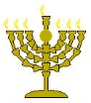

Below is a world map of those visiting TheCreatorsCalendar.com website at this very moment in time. The purpose of showing you these is to encourage you and help you know that you are not alone. Many are waking up as the still small voice speaks to each heart. Only those who “seek with all their heart” will find. (Jeremiah 29:13)

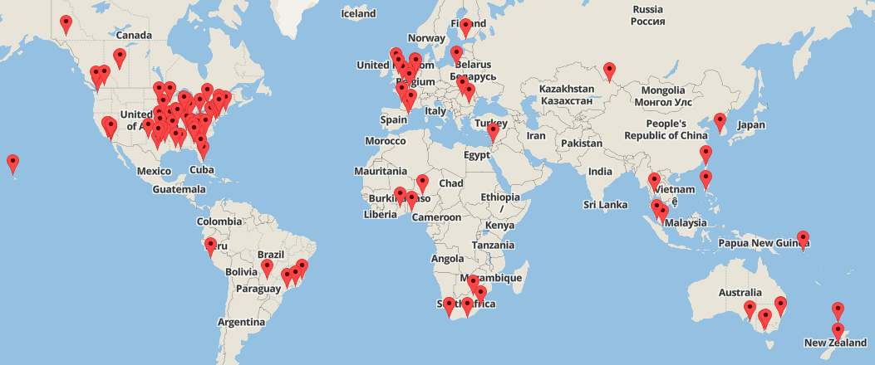

This is from the same moment in time but just an enlarged image of the USA so you can see the details.

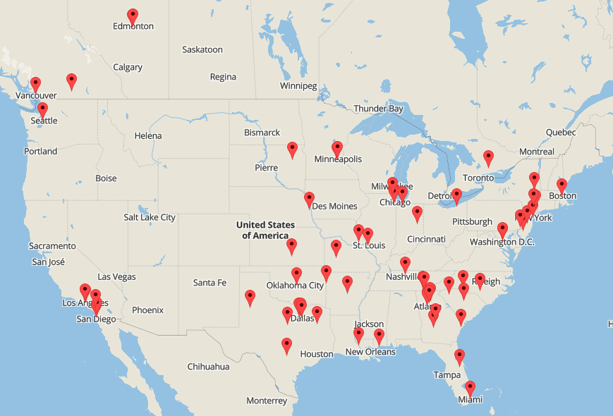

The chart below shows the top 20 most popular articles read at this very moment. To read any of these, simply go to www.TheCreatorsCalendar.com and type the name in the search bar provided on the left side of this website.

