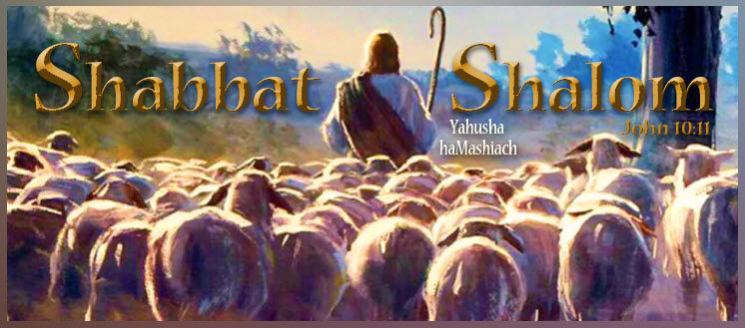
Shabbat Shalom, all who worship Yahuah Alahim and Yahusha haMashiach on their Kadosh (set-apart) New/Renewed Moons, Lunar Sabbaths, and Feast Days according to the full moon as the start of His lunar months!
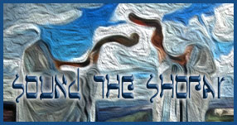
https://www.youtube.com/watch?v=FUb6QjzvRXU

Today is the 15th day of our Creator’s Fifth Lunar Month count, in which the year begins in the spring. It is also the authentic second lunar Sabbath of the month. It looks like 05-15-5995. It coincides with the Roman Gregorian calendar planetary date of Thurs, 08-13-2026.

Our Creator placed His full moon beacon as the original New Moon and the start of His months, high above for all to see. All praise to Yahuah Alahim for His steadfast love and compassion for His children and His patience in restoring His lost truths in preparation for the Second Coming of His Son, Yahusha haMashiach (the Messiah). Simply because the full moon as New Moon, with its count to Lunar Sabbaths and annual Feast Days, is not popular among the Rabbinical Pharisee Jews or the Romanized Christian churches today, does in no way diminish its LIGHT OF TRUTH shining from the pages of Scripture and His Eternal Throne. Only Yahuah’s Ruach (power, presence, and provision) gives those who seek Him with all their hearts “eyes to see and ears to hear.” Ask Him today to reveal His New Moon and lunar Sabbath to you, and see how your life will change as your soul temple is synchronized to His for all eternity.

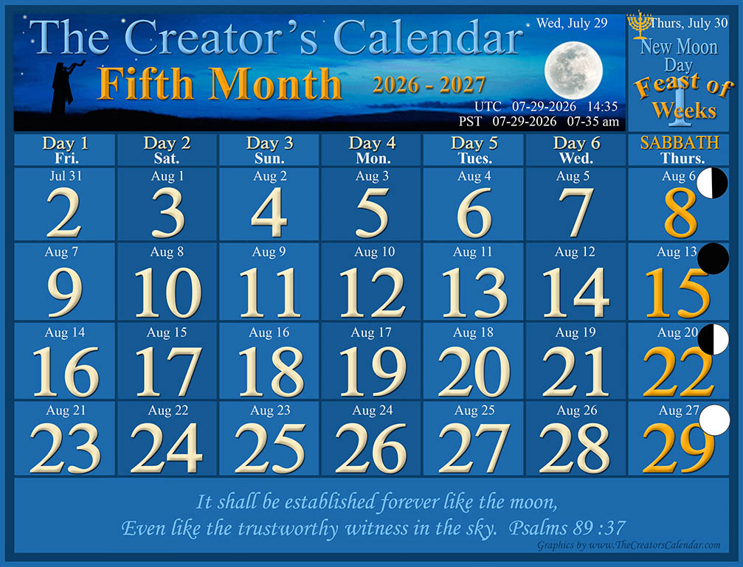

“Blessed are those who hear the joyful call to worship, for they will walk in the light of your presence, Yahuah. They rejoice all day long in your wonderful reputation. They exult in your righteousness.” Psalms 89:15-16
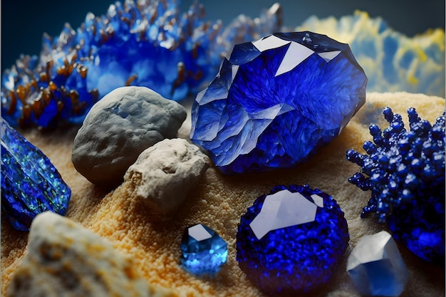

A SPOKEN SAPPHIRE
By Jonathan Cahn
The teacher opened one of the drawers in his desk and took out what appeared to be a precious stone of deep blue. He placed it in my hand.
“It’s a Biblical sapphire.”
“It’s very nice,” I replied, not knowing what else to say.
“I didn’t give it to you because of its appearance, but because of what it signifies…because of its origin.”
“Its origin?”
“The origin of its name,” he said.
“Sapphire?”
“Yes,” said the teacher. “Sapphire comes from a French word, which comes from a Latin word, which comes from a Greek word…which comes from the ancient Biblical Hebrew word…sappire.”
“So sapphire comes from Biblical Hebrew,” I said. “What’s the significance of the name?”
“The Hebrew word for sapphire comes from the Hebrew root saphar. And saphar means to speak, to tell, or to declare.”
“So the word sapphire ultimately means to speak? What’s the connection?”
“The connection is this,” said the teacher. “More precious than any treasured jewel is the Word. Every Word of Yahuah Alahim is a sapphire, a spoken sapphire, and yet much more precious. If one has no treasures in this world, but has the Word of Yahuah, then one is rich. Every Word of Yahuah is a treasure of priceless value. So when you read or hear a Word from Yahuah, receive it as if you were receiving a priceless jewel. And give it the same way.”
“How?”
“Your words are to be as sapphires. You don’t need to possess precious jewels—you just have to speak them. Every time you open your mouth to speak, let what comes out be a sapphire, a gift to be given to those who need to receive a precious jewel. So let every word that comes out of your mouth be a precious jewel. Give jewels to those in need, jewels of blessing, jewels of encouragement, jewels of strength, jewels of mercy, jewels of love, jewels of forgiveness, jewels of joy, and jewels of hope. Let your every word bring life to those who hear it…an audible jewel… a spoken sapphire.”
The Mission: Today, make every word that comes out of your mouth a precious jewel, a gift of life, the spoken sapphire. Ephesians 4:29; 5:19; Colossians 4:6; 1 Peter 4:11; Proverbs 15:1, Proverbs 25:11.
Disclaimer: “The Book of Mysteries” by Jonathan Cahn presents a series of lessons he attributes to “The Teacher” in the land of Yasharal (Israel). While we do not affirm all of Cahn’s interpretations or theological positions, we welcome the insights that harmonize with Scripture.

“A word fitly spoken is like apples of gold in pictures of silver.” Proverbs 25:11
“A soft answer turns away wrath, but a harsh word stirs up anger.” Proverbs 15:1
“Let no corrupt word proceed out of your mouth, but what is good for necessary edification, that it may impart grace to the hearers.” Ephesians 4:29
“And do not be drunk with wine, in which is dissipation; but be filled with the Ruach haKadosh, speaking to one another in psalms and hymns and spiritual songs, singing and making melody in your heart to YAHUAH, giving thanks always for all things to Alahim the Father in the name of our Master, Yahusha haMashiach, submitting to one another in the honor of Alahim.” Ephesians 5:18-21
“Let your speech always be with grace, seasoned with salt, that you may know how you ought to answer each one.” Colossians 4:6
“If anyone speaks, let him speak as the oracles of Yahuah Alahim. If anyone ministers, let him do it as with the ability which Yahuah Alahim supplies that in all things Yahuah Alahim may be glorified through Yahusha haMashiach, to whom belong the glory and the dominion forever and ever.” 1 Peter 4:11

“YAHUAH their Alahim will save them in that day, as the flock of His people. For they shall be like the jewels of a crown, Lifted like a banner over His land.” Zechariah 9:16

“They shall be Mine," says YAHUAH of hosts, "On the day that I make them My jewels. And I will spare them as a man spares his own son who serves him." Malachi 3:17

A Spoken Sapphire
A sapphire rests within my hand,
A stone from creation’s early land,
Its deep blue hue, a silent voice,
It whispers, urging me, "Rejoice!"
The teacher's eyes, so earnest bright,
Revealed the gem's true, sacred light.
"It's not the stone, its value rare,
But what it speaks, great words to bear."
From Hebrew roots, the meaning flows,
"Saphar" declares, the word bestows,
A voice to speak, a truth to tell,
A treasure more than gems compel.
Every word from YAH's sacred throne,
Is precious as this sapphire stone,
A spoken jewel, a gift divine,
To those who need His light to shine.
"Your words," he said, "must be the same,
As sapphires pure, in YAH's blessed name,
For when you speak, let truth impart,
A jewel to heal the broken heart."
No riches needed, just the will,
To speak with grace, the heart to fill,
With words of mercy, strength, and peace,
To help the bonds of sorrow cease.
So every sentence, every phrase,
Becomes a sapphire in His ways,
A gem of love, a gift of hope,
To help the weary soul to cope.
Let not corrupt words cross your lips,
But only those that grace equips,
For every word that you bestow,
Must shine with Heaven’s gentle glow.
Speak psalms and hymns, and songs of praise,
In every moment, all your days,
Let melody within your heart,
From YAHUAH's joy, to impart.
With kindness etched upon your face,
And speech seasoned with holy grace,
Let every answer that you give,
Reflect the way you choose to live.
For if you speak, let truth be heard,
As oracles of YAH’s sacred Word,
In all you do, in every breath,
Proclaim His glory, unto death.
In His hands, we are His jewels,
To reach the lost, as sacred tools.
Of treasure, gold, or diamond's gleam,
We are His crown, His chosen theme.
On that great day, we'll shine as bright,
As sapphires in the morning light,
His flock, His gems, His precious few,
Will rise, adorned with Heaven’s hue.
So speak with care, and speak with love,
And honor YAHUAH who is above,
For every word, a sapphire clear,
To bless the ones who need to hear.
And in the end, when all is told,
These spoken gems, more prized than gold,
Will bear the mark of YAHUAH’s hand,
A treasure rich, in His promised land.

Song: Spoken Sapphires ~ Kerrie French
https://suno.com/song/21b9183d-7ad4-4c11-90b1-bde94fe51639

Witness in the Sky ~ Kerrie French
https://suno.com/song/10391779-0630-4fe7-bf48-4562200fc3ba

Prayer:
YAHUAH, place within our hearts words that are pure as sapphires,
filled with truth, mercy, grace, and the
gentle light of Heaven.
Teach us to speak in ways that strengthen the weary, comfort
the brokenhearted, and reflect the beauty of Your
sacred Word in every conversation.
May our lips become instruments of praise and blessing, so
that every word we offer bears the mark of Your
love and brings glory to Your holy name.

Barak hashem Yahusha haMashiach!
(Bless the name of Yahusha the Messiah!)

Kerrie French
www.TheCreatorsCalendar.com
TheCreatorsCalendar29.5@gmail.com
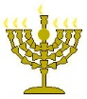

Below is a world map of those visiting TheCreatorsCalendar.com at this very moment in time. The purpose of showing you these is to encourage you and help you know that you are not alone. Many are waking up as Yahusha’s still, small voice speaks to each heart. Only those who “seek with all their heart” will find. (Jeremiah 29:13)
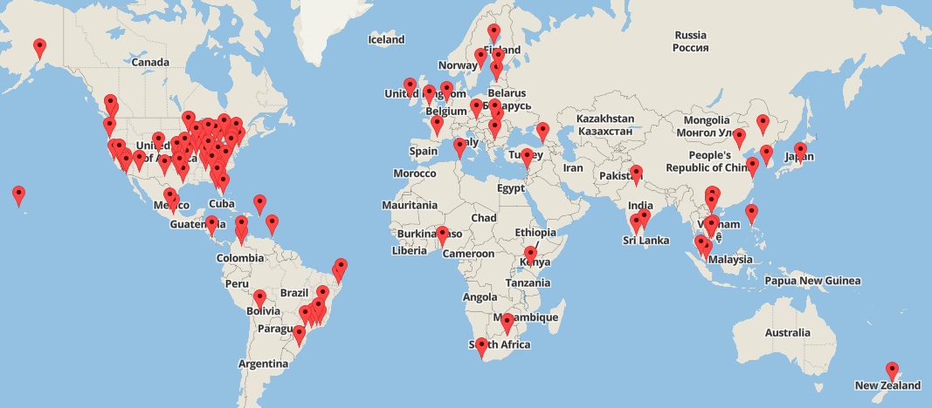

This is from the exact moment in time, but an enlargement of the USA, so you can see the details.


The chart below shows the top 16 most popular articles read at this very moment. To read any of these, simply go to www.TheCreatorsCalendar.com and type the article name in the search bar provided near the top left corner of this web page.
